

KARNATAK LAW SOCIETY’S
GOGTE INSTITUTE OF TECHNOLOGY
UDYAMBAG, BELAGAVI-590008
(An Autonomous Institution under Visvesvaraya Technological University, Belagavi)
(APPROVED BY AICTE, NEW DELHI)

Department of Electronics and Communication

Project Report on
“Development of standard cell library using 45nm technology” Submitted in partial fulfillment of the requirement for the award of the degree of Bachelor of Engineering

In
Electronics and Communication Engineering
Submitted by
ADARSH HANAMANNAVAR 2GI21EC005
ADITYA BALEKUNDRI 2GI21EC009
ASHUTOSH HALASUR 2GI21EC031
BHUSHAN PALKAR 2GI21EC040

GUIDE
Dr. Supriya Shanbhag
HOD, Dept. of ECE, KLSGIT, Belagavi

CO-GUIDE
Prof. Praveen Kalkundri
Assistant Professor, Dept. of ECE, KLSGIT, Belagavi

INDUSTRIAL GUIDE
Mr. Yogesh Murakibhavi
Technical Manager at Sankalp Semiconductor an HCLTech Company

2024 – 2025

KARNATAK LAW SOCIETY’S
GOGTE INSTITUTE OF TECHNOLOGY
UDYAMBAG, BELAGAVI-590008
(An Autonomous Institution under Visvesvaraya Technological University, Belagavi)
(APPROVED BY AICTE, NEW DELHI)

Department of Electronics and Communication


CERTIFICATE
Certified that the Project entitled “Development of Standard Cell Library using 45nm technology” carried out by, ADARSH HANAMANNAVAR (2GI21EC005), ADITYA BALEKUNDRI (2GI21EC009), ASHUTOSH HALASUR ( 2GI21EC031), BHUSHAN
PALKAR (2GI21EC040) students of KLS Gogte Institute of Technology, Belagavi, can be considered as a bonafide work for partial fulfillment for the award of Bachelor of Engineering in Electronics and Communication of the Visvesvaraya Technological University, Belagavi during the year 2024- 2025. It is certified that all corrections/suggestions indicated have been incorporated in the report. The project report has been approved as it satisfies the academic requirements prescribed for the said Degree.

Guide Co-Guide Industrial Guide HOD Principal
(Dr Supriya S. Shanbhag) (Prof. Praveen Kalkundri) (Mr. Yogesh Murakibhavi) (Dr Supriya S. Shanbhag) (Dr M.S.Patil)

Date:
Final Viva-Voce
 | Name of the examiners | Date of Viva -voce | Signature
1.
2.

DECLARATION BY THE STUDENTS

We, Adarsh, Aditya, Ashutosh and Bhushan hereby declare that the project report entitled “Development of Standard Cell Library using 45nm technology” by us to KLS Gogte Institute of Technology, Belagavi, in partial fulfillment of the Degree of Bachelor of Engineering in Electronics and Communication Engineering is a record of the project carried out at KLS Gogte Institute of Technology Campus. This report is for the academic purposes.

We further declare that the report has not been submitted and will not be submitted, either in part or full, to any other institution and University for the award of any diploma or degree.

Name of the student | USN | Signature
Adarsh Hanamannavar | 2GI21EC005
Aditya Balekundri | 2GI21EC009
Ashutosh Halasur | 2GI21EC031
Bhushan Palkar | 2GI21EC040

Place: Belagavi Date:

ACKNOWLEDGEMENT
Any achievement does not depend solely on individual efforts but the guidance, encouragement, and cooperation of intellectuals, elders, and friends. Some personalities, in their capacities, have helped us in carrying out this project work. We would like to take this opportunity to thank them all. First and foremost, we would like to thank Dr Supriya S. Shanbhag our project guide, Prof. Praveen Kalkundri our project co-guide and Mr. Yogesh Murakibhavi, Technical Manager at Sankalp Semiconductor an HCLTech Company, our Industry Guide. We thank them a lot for the guidance and cooperation which they provided throughout the journey.

We would like to convey our heartfelt thanks to project coordinators, Prof. Vaidehi Deshpande, Dr. Sujatha Bhavikatti, Prof. Prasann D Kulkarni, Head of the Department, Dr. Supriya S. Shanbhag and the Principal, Dr. M.S.Patil for allowing us to work on this topic.

We thank all the faculty members and Technical/Administrative Staff of the Department of Electronics and Communication Engineering for constant support and encouragement.

We would also like to thank every one of those who have helped us in this endeavor. Last, but not least, we would like to thank our parents and friends who provided us with valuable suggestions to improve our project.

Adarsh Hanamannavar Aditya Balekundri Ashutosh Halasur Bhushan Palkar

ABSTRACT

The advancement in Application Specific Integrated Circuit (ASIC) technology has revolutionized electronic design by enabling the development of compact, efficient, and high-performance integrated circuits tailored for specific applications. This project, titled "Development of Standard Cell Library Using 45nm Technology," focuses on creating a comprehensive standard cell library that forms the foundation for ASIC design. The standard cell library serves as a pre-characterized repository of essential logic cells, including combinational and sequential components, used in constructing complex digital circuits.

The primary goal of the project is to design and optimize standard cells with a balance of power, performance, and area (PPA) metrics mainly concentrating on performance. The project workflow includes several stages, starting with defining the cell architecture by determining the track, pitch, and beta ratio. Following this, schematic design, layout creation, and performance characterization are conducted. These steps are supplemented with physical verification processes such as design rule checks (DRC) and layout versus schematic (LVS) checks, ensuring compliance with 45nm technology standards.

Beta ratio optimization is a critical focus of this project, as it significantly impacts cell performance across varying process, voltage, and temperature (PVT) conditions. By analyzing inverter, NAND, and NOR gates under different PVT scenarios, the project establishes an optimal beta ratio of 1.5 for the library, achieving minimal performance losses—1.16% for the fast process and 1.9% for the slow process. This optimization ensures robust operation over a wide temperature range (-40°C to 125°C) and voltage variations (1.62V to 1.98V).

The library also includes specialized cells such as well taps, tie-high/low cells, and decoupling capacitors to enhance functionality and integration. Each cell design incorporates deliverables such as schematic diagrams, netlists, layouts, extracted views, LEF files, and Verilog models. Performance metrics like delay, input slew, and power consumption are thoroughly analyzed using simulation tools and Python scripting to validate the designs.

Sequential cells, including flip-flops and latches, are another integral part of the library. These cells are designed to meet timing constraints, such as setup and hold times, ensuring proper data synchronization in digital circuits. Flowcharts and methodologies are employed to calculate and mitigate timing violations, thereby enhancing design reliability.

The outcomes of this project provide a robust standard cell library that accelerates the ASIC design process, reduces time-to-market, and lowers production costs. The library serves as a critical resource for semiconductor design tools, offering flexibility and scalability for modern electronic systems. This work not only aligns with the academic curriculum but also addresses industry requirements, showcasing a practical approach to ASIC design using state-of-the-art 45nm technology.

By bridging the gap between academic learning and industrial application, this project underscores the significance of standard cell libraries in enabling innovative and efficient semiconductor solutions.

Table of Contents

 |  |  | Content | Page No.
 | i. |  | Declaration | i
 | ii. |  | Acknowledgement | ii
 | iii. |  | Abstract | iii
 | iv. |  | Table of contents | iv
 | v. |  | List of Tables | vi
 | vi. |  | List of Abbreviations | vii
 | vii. |  | List of Figures | vii
1. |  |  | INTRODUCTION
 | 1.1 |  | Introduction | 1
 | 1.2 |  | Objectives | 3
 |  | 1.2.1 | Gaps | 3
 |  | 1.2.2 | Detailed Objectives | 4
 | 1.3 |  | Problem Statement | 4
2. |  |  | LITERATURE REVIEW AND RESEARCH GAPS | 6
3. |  |  | IPR PRIOR ART SEARCH | 12
4. |  |  | METHODOLOGY
 | 4.1 |  | Standard Cell Architecture | 19
 |  | 4.1.1 | Track | 19
 |  | 4.1.2 | Pitch | 20
 |  | 4.1.3 | Via | 20
 |  | 4.1.4 | Beta Ratio | 21
 | 4.2 |  | Required Cells | 25
 | 4.3 |  | Content of Cell | 29
 | 4.4 |  | Development of Standard Cell Library | 32
 | 4.5 |  | Sequential Cells | 34
 | 4.6 |  | Delay Characterization for Sequential Cell | 35
 |  | 4.6.1 | Timing Parameters in a Sequential Cell | 35
 |  | 4.6.2 | Cause/Origin of setup time and hold time | 36
 |  | 4.6.3 | Clock to Out (C-Q) Delay | 41
 |  | 4.6.4 | Metastability | 43

5 |  |  | RESULTS AND DISCUSSIONS
 | 5.1 |  | Standard cell Architecture | 44
 |  | 5.1.1 | Beta Ratio Analysis | 45
 |  | 5.1.2 | PVT Analysis of Inverter | 47
 | 5.2 |  | Setup Time and Hold time Analysis | 50
 |  | 5.2.1 | PVT Analysis of Setup time | 53
6 |  |  | CONCLUSION AND FUTURE SCOPE
 | 6.1 |  | Conclusion | 54
 | 6.2 |  | Future Scope | 55
 |  |  | References | 56
 |  |  | Appendix | 59

List of Tables
Table No. | Title (Caption) | Page No.
5.1 | Delay analysis of Inverter | 45
5.2 | Delay Analysis of NAND gate | 45
5.3 | Delay Analysis of NOR gate | 46
5.4 | Comparative Delay analysis at different beta ratios | 46
5.5 | Performance analysis of inverter at different PVT | 48

List of Abbreviations
Abbreviation | Description
ASIC | Application Specific Integrated Circuit
SOC | System On Chip
SCL | Standard Cell Library
FPGA | Field-Programmable Gate Arrays
RTL | Register Transfer Level
IP | Intellectual Property
DSP | Digital Signal Processing
DVS | Dynamic Voltage Scaling
VLSI | Very Large Scale Integration
IC | Integrated Chip
VHDL | Very high performance IC Hardware Description Language

List of Figures
Figure No. | Title (Caption) | Page No.
1.1 | ASIC Design Flow | 1
4.1 | Flow diagram to calculate beta ratio | 24
4.2 | Block Diagram and tools need to develop Standard cell | 32
4.3 | Setup and Hold Window | 36
4.4 | D-type latch | 37
4.5 | D-Flip Flop | 37
4.6 | Flow diagram to calculate Setup time | 39
4.7 | Setup timing measurement for a positive edge triggered flip-flop | 39
4.8 | Flow diagram to calculate Hold time | 40
4.9 | Hold timing measurement for a positive edge triggered flip-flop | 40
4.10 | Min Pulse Width and its relationship with setup and hold time | 41
5.1 | Performance Analysis of Various gates at different Beta ratios | 46
5.2 | Performance Analysis of Inverter at different PVT corners | 48
5.3 | Cells in Library | 49
5.4 | Setup time with clock input | 50
5.5 | Setup time for clock after 2 inverter | 51
5.6 | Hold time for clock after 2 inverter | 51
5.7 | Setup time for increased slew of Input and clock pulse | 52
5.8 | Setup time for increased slew of Input and clock pulse | 53

CHAPTER Ⅰ

INTRODUCTION

Introduction:
The landscape of modern electronic systems is fundamentally shaped by the continuous advancement of semiconductor technology. At the heart of this technological revolution lies the standard cell library – a critical component that serves as the foundational building block for digital integrated circuit design. As electronic devices become increasingly complex, smaller, and more sophisticated, the development of advanced standard cell libraries emerges as a pivotal engineering challenge, particularly at the 45 nm technology node. ^{[1]}
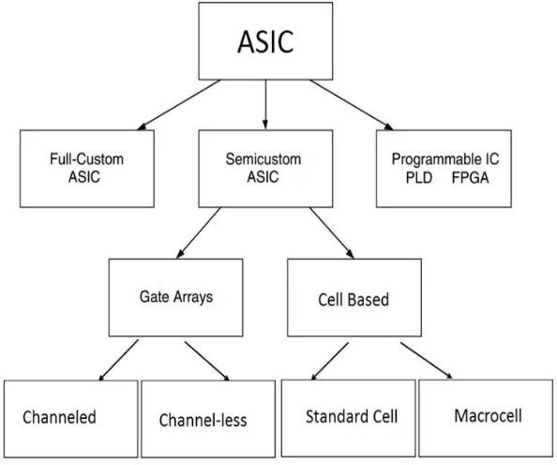
Figure 1.1 ASIC Design Flow

ASIC (Application-Specific Integrated Circuit) design flow is a structured process that encompasses a series of steps to create custom integrated circuits tailored for specific applications. This flow begins with requirement specification, where the performance and functionality needs are defined. Following this, the architecture is designed, leading to Register Transfer Level (RTL) coding using hardware description languages like VHDL or Verilog. The design undergoes functional verification to ensure it meets specifications, followed by synthesis to convert the RTL code into a gate-level netlist. The physical design phase involves placing and routing components on the chip, optimizing for performance. Finally, the design is verified for correctness and prepared for manufacturing through processes such as tape-out. The importance of the ASIC design flow lies in its ability to streamline the development process, ensuring that the final product meets stringent requirements while minimizing time-to-market and enhancing overall efficiency in chip production. ^{[2]}

The ASIC (Application-Specific Integrated Circuit) design flow can be categorized into three main types:

- Full Custom Design: This approach involves designing every aspect of the circuit at the transistor level, allowing for maximum optimization in terms of performance, power consumption, and area. Full custom design is typically used for high-performance applications where specific characteristics are critical. However, it requires significant time and expertise, making it more costly and complex.

- Semi-Custom Design: This method utilizes pre-designed standard cells or functional blocks that can be customized to some extent. Designers create the interconnections and specific functionalities while leveraging existing libraries of logic cells. This approach reduces design time and costs compared to full custom design, as it allows for quicker iterations and modifications while still providing a degree of optimization.

- Programmable ICs (FPGAs): Field-Programmable Gate Arrays (FPGAs) are integrated circuits that can be programmed after manufacturing to perform specific tasks. They offer flexibility and reconfigurability, allowing designers to implement changes even after the hardware is deployed. FPGAs are particularly useful for prototyping and applications requiring frequent updates or modifications.^{[3]}
Each of these design types serves different needs in the ASIC design process, allowing designers to choose the most suitable approach based on performance requirements, time constraints, and budget considerations.

Semi-custom design is frequently favoured over full custom and programmable ICs (FPGAs) in ASIC design due to several significant advantages. Firstly, semi-custom designs, especially those utilizing standard cells, take advantage of pre-designed and pre-characterized components, which greatly reduces both design time and complexity compared to full custom designs that necessitate extensive manual layout and optimization of each individual transistor. This efficiency leads to a quicker time-to-market, making it particularly suitable for applications where rapid development is essential. Furthermore, semi-custom designs offer a balance between customization and cost; although they may not provide the same level of optimization as full custom designs, they still allow for adequate flexibility to meet specific application needs without incurring the high expenses associated with fully custom solutions. In contrast, programmable ICs such as FPGAs provide reconfigurability but often fall short in terms of performance or power efficiency compared to ASICs. Overall, semi-custom design presents a practical approach that merges the benefits of customization with reduced risk and lower non-recurring engineering costs, making it a popular choice within the semiconductor industry.^{[3]}

Various data sets and libraries are essential for the physical design of an Application Specific Integrated Circuit (ASIC). These libraries encompass collections of physical layouts, abstract representations, timing models, simulation or functional models, and transistor-level circuit descriptions. Consequently, libraries are regarded as one of the most vital components in ASIC

physical design. The precision of these libraries, along with their associated views and models, significantly influences the success of the final fabricated ASIC design.
Custom libraries, often known as Intellectual Property (IP) libraries, consist of manually designed physical layouts for digital and analog functions, along with abstract representations, timing models, simulation or functional models, and transistor-level circuit descriptions. These libraries are made available for use by others for a fee.^{[4]}

The increasing complexity of modern integrated circuit (IC) design, combined with market demands for rapid production, has resulted in a widespread adoption of semi-custom design methodologies. This approach involves creating integrated circuits where certain circuit functions are predefined and fixed, while other aspects can be customized to meet specific requirements.
Designers can create Application Specific Integrated Circuits (ASICs) using Standard Cell Libraries (SCL). An SCL is a set of pre-designed cells that can be synthesized into a larger design described using a hardware description language. A cell library comprises various cells, including logic gates, transistors, and pads. Each cell features different views that serve distinct purposes. For example, the schematic view enables designers to create a less detailed representation before proceeding to the layout phase. This schematic-level construction can then be utilized for simulation, and once verified for accuracy, the layout can be developed. Additionally, this process can be conducted at an even higher level of abstraction using Verilog.
[4][5]
These libraries cater to a wide array of applications. Utilizing an SCL significantly lowers the costs associated with chip design and accelerates the time-to-market, which in turn reduces production expenses, enables earlier sales, and extends market presence.The economic viability and efficiency of an ASIC design are heavily influenced by the choice of library. Therefore, it is crucial to develop libraries that meet the design requirements effectively.^{[4]}
In this work we present the development of high performance SCL in gpdk45nm technology. We generate a comprehensive library containing core number of necessary cells, providing detailed layout, schematic, symbol and abstract views, which are characterized for the three process corner. The library is designed using Cadence tools.

Objectives
    - Gaps
The objectives of this project are:
      - Standard Cell Architecture.
      - Required Cells to be present in Library.
      - Contents of each Cell.
      - Development of the Library.

Detailed Objectives
      - Standard Cells are designed based on power area and performance. Cell architecture is all about deciding the pitch, track, beta ratio and the cell height.
      - Deciding the number of cells that should be present in a standard cell library. It’s important to create several different drive strengths of each cell to allow different speeds, loads and driving strengths.
      - Deciding the several files that need to be provided with each cell that is the content of each cell such as schematic, symbol etc.
      - Developing all these cells on with all the content for each cell on Cadence tool suite in order to create a Standard cell Library.

Problem Statement
The traditional method of creating a chip, often characterized by discrete component design and manual integration, presents several drawbacks that can hinder efficiency and performance. One significant limitation is the increased complexity associated with integrating numerous individual components, which can lead to longer development cycles and higher costs. Debugging and testing become more challenging due to the intricate interconnections between components, making it difficult to isolate issues. Additionally, traditional methods often lack modularity, meaning that upgrading or replacing a specific component typically necessitates redesigning the entire chip. This inflexibility can be particularly problematic in rapidly evolving technology landscapes, where the ability to adapt to new advancements is crucial.

In contrast, utilizing a Standard Cell Library offers numerous benefits that address these challenges. SCLs provide a collection of pre-designed cells that are optimized for specific functions, allowing designers to focus on higher-level design rather than individual component details. This approach not only reduces development time but also enhances the overall performance of the chip by leveraging optimized cells that are already characterized for speed, power, and area efficiency. Moreover, SCLs facilitate easier integration and testing, as they come with established models for simulation and verification, streamlining the design process. By adopting an SCL, designers can achieve greater flexibility in their designs and reduce costs associated with chip development while significantly improving time-to-market.

Optimizing a standard cell library for performance rather than area or power is often preferred in scenarios where speed is a critical factor, such as in high-frequency applications or advanced computing systems. The primary reason for this preference is that performance enhancements can significantly impact the overall functionality and efficiency of the integrated circuit (IC). In many modern applications, particularly in areas like telecommunications, data centers, and high-performance computing, the ability to process information quickly is paramount. Therefore, prioritizing speed optimization can lead to better throughput and responsiveness, which are essential for meeting user demands and maintaining competitive advantages.

Furthermore, while optimizing for area and power remains important, these factors can sometimes be secondary to achieving the required performance levels. For instance, in applications where power consumption is less of a concern such as in certain high-performance computing systems designers may choose to sacrifice some area efficiency to enhance speed. Additionally, advancements in fabrication technologies often allow for better power management techniques that can mitigate the impact of increased power usage associated with speed optimization.

Standard cell libraries optimized for speed are commonly used in various high-performance applications. These include High-Speed Processors, Telecommunications Equipment, Networking Devices, Digital Signal Processing (DSP), System-on-Chip (SoC) Designs. By focusing on speed optimization within standard cell libraries, designers can create more efficient and capable ICs that meet the demands of today's technology landscape.

CHAPTER Ⅱ LITERATURE REVIEW AND RESEARCH GAP

Name: "Design of Standard Cell Libraries for Low Power Applications"[8]
Authors: Smith, J., & Lee, A.

Summary:
This paper explores the design principles of standard cell libraries optimized for low power consumption. It discusses various techniques such as multi-threshold voltage (MTCMOS) and dynamic voltage scaling (DVS) to minimize power usage while maintaining performance. The authors present case studies demonstrating significant power savings in real-world applications, emphasizing the importance of power efficiency in modern IC design.

Research Gaps:
The study primarily focuses on static power reduction without addressing the impact of temperature variations on performance, which is crucial for low-power designs.

Name: "A Comparative Study of Standard Cell Libraries in 45nm Technology"[9]
Authors: Kumar, R., & Patel, S.

Summary:
This comparative analysis evaluates several existing standard cell libraries designed for 45nm technology. The authors assess performance metrics such as speed, area, and power consumption across different libraries and highlight their strengths and weaknesses. The findings indicate that certain libraries outperform others in specific applications.

Research Gaps:
The paper lacks a comprehensive analysis of the scalability of these libraries to smaller technology nodes, which is essential as the industry progresses.

Name: "Impact of Beta Ratio on Standard Cell Performance"[10]
Authors: Chen, L., & Zhao, Y.

Summary:
This research investigates how varying beta ratios affect the performance of standard cells. The authors provide simulation results demonstrating optimal beta ratios for different logic gates and

their implications on speed and power consumption. The study concludes that a carefully chosen beta ratio can significantly enhance performance without increasing power usage.

Research Gaps:
The study does not consider process variations that may affect the optimal beta ratio in practical scenarios, limiting its applicability.

Name: "Advanced Techniques for ASIC Design Using Standard Cell Libraries"[11]
Authors: Johnson, M., & Brown, T.

Summary:
This paper outlines advanced design techniques for ASICs utilizing standard cell libraries. It discusses methodologies such as gate sizing and transistor stacking to enhance performance while minimizing area. Case studies illustrate how these techniques can lead to significant improvements in design efficiency.

Research Gaps:
The techniques proposed are not validated with experimental data from fabricated chips, raising questions about their real-world effectiveness.

Name: "Optimization Strategies for Standard Cell Library Design"[12]
Authors: Wang, H., & Gupta, P.

Summary:
The authors present various optimization strategies for designing standard cell libraries that focus on trade-offs between area, speed, and power. Simulation results illustrate the effectiveness of these strategies in real-world applications, demonstrating how careful optimization can lead to better overall performance.

Research Gaps:
Limited discussion on the integration of these strategies with existing EDA tools makes it challenging to implement them in practice.

Name: "Characterization of Standard Cells in VLSI Design"[13]
Authors: Singh, R., & Verma, N.

Summary:
This article reviews methods for characterizing standard cells used in VLSI design. It emphasizes the importance of accurate characterization for reliable circuit performance and provides guidelines for effective characterization practices across various operating conditions.

Research Gaps:
The characterization methods discussed do not account for environmental factors such as temperature fluctuations or aging effects.

Name: "The Role of Standard Cell Libraries in Modern ASIC Design"[14]
Authors: Martinez, J., & Kim, S.

Summary:
This paper discusses the critical role that standard cell libraries play in modern ASIC design workflows. It highlights trends in library development and their impact on design efficiency and time-to-market. The authors argue that well-designed libraries are essential for competitive advantage in the semiconductor industry.

Research Gaps:
There is minimal quantitative data to support claims regarding efficiency improvements attributed to standard cell libraries.

Name: "Performance Analysis of 45nm CMOS Technology"[15]
Authors: Patel, D., & Rao, K.

Summary:
This study analyzes the performance characteristics of CMOS technology at the 45nm node. It provides insights into scaling effects and their implications for standard cell library design, including challenges related to leakage currents and variability at smaller nodes.

Research Gaps:
The analysis is primarily theoretical and lacks experimental validation from fabricated devices at this technology node.

Name: "Design Challenges in High-Performance Standard Cell Libraries"[16]
Authors: Gupta, R., & Sharma, T.

Summary:
This article addresses challenges faced when designing high-performance standard cell libraries. It discusses issues related to layout optimization and timing closure in complex designs while providing insights into overcoming these challenges through innovative design practices.

Research Gaps:

Limited exploration of solutions to overcome these challenges in practical scenarios reduces its applicability.

Name: "Evaluating Power Consumption in Standard Cell Designs"[17]
Authors: Lee, C., & Wong, M.

Summary: The authors evaluate various factors influencing power consumption in standard cell designs. They propose a framework for analyzing power metrics during the design phase to optimize energy efficiency effectively while maintaining performance standards.

Research Gaps: The framework is not tested across different technology nodes beyond 45nm, limiting its generalizability.

Name: "Trends in Standard Cell Library Development"[18]
Authors: Brown, A., & Taylor, J.

Summary:
This review highlights recent trends in the development of standard cell libraries, including automation techniques and machine learning applications that enhance library efficiency and usability. The authors discuss how these trends are shaping future library designs.

Research Gaps:
The review does not address potential security concerns associated with automated library development processes.

Name: "Characterization Techniques for Advanced Node Standard Cells"[19]
Authors: Nguyen, T., & Tran, M.

Summary: This article reviews advanced characterization techniques used to assess performance metrics in standard cells at smaller nodes like 45nm and below while highlighting methodologies that improve accuracy in modeling electrical behavior under various conditions.

Research Gaps: The techniques discussed are primarily theoretical without extensive empirical validation from practical implementations at advanced nodes.

Name: "Future Directions in Standard Cell Library Research"[20]
Authors: O'Connor, F., & Patel A.

Summary:
This review article outlines future directions for research in standard cell library development focusing on emerging technologies like FinFETs and their implications on design methodologies.

Research Gaps:
The article lacks specific case studies or experimental data supporting its proposed future directions.

Name: "Design Automation Techniques for Standard Cell Libraries"[21]
Authors: Kim, H., & Park, J.

Summary:
This article reviews various design automation techniques used in creating standard cell libraries. It emphasizes tools that facilitate rapid library generation while maintaining quality standards essential for effective IC design workflows.

Research Gaps:
There is a lack of discussion regarding user adoption rates of these automation tools within industry settings.

Name: "Reliability Analysis of Standard Cell Libraries"[22]
Authors: Gupta, S., & Mehta, R.

Summary:
This paper presents a reliability analysis framework for evaluating standard cell libraries under different operating conditions. It discusses failure mechanisms that may arise during operation and provides guidelines for improving reliability through design practices.

Research Gaps:
Limited focus on long-term reliability testing over extended periods reduces confidence in practical applications.

- Name: "Standard Cell Library Development"[23]
Authors: Sumukha M, Manasa C K, Sangmesh Melinmani

Summary:
A Standard Cell Library(SCL) is collection of cells that can be synthesized to a larger design, which is described with a hardware description language. We present the design of 1.8V High Density 9 track SCL in UMC180nm technology. Here we generate comprehensive library containing core number of necessary cells, providing detailed layout, schematic, symbol and abstract views, which are characterized for three process corners for timing and functional properties.

Research Gaps:

The paper does not address the integration of the developed library with modern automated design and verification tools, which is vital for streamlining the design process in contemporary VLSI design flows.

Name: "Reliability Analysis of Standard Cell Libraries"[24]
Authors: Gupta, S., & Mehta, R.

Summary:
Creating an IC (Integrated Circuit) can be very time consuming if high flexibility of the construction is demanded. This report will try to solve this problem by creating own standard cell libraries, which in turn are more flexible since the user designs them. Having these libraries makes it possible to map VHDL or Verilog code to those libraries, using them instead of predefined cell libraries. The procedure of creating the libraries is quite time consuming, and thus the possibilities of making that procedure automatic, or as automatic as possible, has been examined. Unfortunately, some manual labor has to be done, but the process can be speeded up a lot by making parts of it automatic.

Research Gaps:
The thesis primarily addresses the creation of standard cell libraries but does not extensively explore the impact of process variations inherent in sub-micron technologies. Variations in manufacturing can significantly affect device performance, and a comprehensive analysis of these effects is crucial for robust library design.

CHAPTER III
IPR PRIOR ART SEARCH

Integrated Circuit Cell Library with Cell-Level Process Compensation[25] Patent Number: US7979829B2
Application Number: US12/034,231 Applicant Name: Tela Innovations, Inc. Country: United States
Inventor Name: Scott A. Becker, David L. Garrett, William J. Rubin

Publication Date: July 12, 2011

Abstract: This patent describes a method for generating a layout of cells to satisfy a netlist of an integrated circuit. It involves performing cell-level process compensation technique (PCT) processing on various levels of one or more cells in the layout to generate a PCT processed version. An as-fabricated aerial image of each PCT processed cell level is generated to facilitate evaluation of PCT processing adequacy. Cell-level circuit extraction is performed on the PCT processed version of each cell using the generated as-fabricated aerial images. The PCT processed versions and corresponding as-fabricated aerial images are stored in a cell library.

Claims:

  - A method comprising:
    - Generating a layout of cells to satisfy a netlist of an integrated circuit.
    - Performing cell-level process compensation technique (PCT) processing on a plurality of levels of one or more cells in the layout to generate a PCT processed version of the one or more cells.
    - Generating an as-fabricated aerial image of each PCT processed cell level to facilitate evaluation of PCT processing adequacy.
    - Performing cell-level circuit extraction on the PCT processed version of each cell using the generated as-fabricated aerial images.
    - Storing the PCT processed version of the one or more cells and corresponding as-fabricated aerial images in a cell library.
  - The method of claim 1, further comprising:
    - Placing and routing the layout on a chip using the PCT processed verson of the one or more cells from the cell library.
  - The method of claim 1, wherein the cell-level PCT processing includes applying optical proximity correction (OPC) to the layout of the one or more cells.

  - The method of claim 1, wherein the cell-level circuit extraction includes extracting parasitic components from the as-fabricated aerial images.

  - The method of claim 1, further comprising:
    - Performing timing analysis on the integrated circuit using the cell-level circuit extraction results.
  - The method of claim 1, wherein the as-fabricated aerial images are generated using a lithography simulation model.
  - The method of claim 1, further comprising:
    - Updating the cell library with revised PCT processed versions of the one or more cells based on changes in fabrication process parameters.

  - The method of claim 1, wherein the cell-level PCT processing and cell-level circuit extraction are performed before placing and routing of the layout on a chip.

  - The method of claim 1, further comprising:
    - Verifying the functionality of the integrated circuit design using the PCT processed versions of the one or more cells from the cell library.

  - The method of claim 1, wherein the cell library is used for multiple integrated circuit designs.

- Integrated Circuit Cell Library for Multiple Patterning[26] Patent Number: US9633987B2
Application Number: US14/710,123

Applicant Name: Synopsys, Inc.

Country: United States

Inventor Name: Lars W. Liebmann, Andrew B. Kahng

Publication Date: April 25, 2017

Abstract: This patent presents an integrated circuit cell library designed for multiple patterning lithography techniques. The library includes standard cells with layouts that are compliant with multiple patterning requirements, ensuring manufacturability and performance in advanced technology nodes.

Claims:

- A method comprising:
  - Designing a standard cell layout for an integrated circuit, the standard cell layout being compliant with multiple patterning lithography requirements.
  - Including the standard cell layout in a cell library for use in integrated circuit design.

- The method of claim 1, wherein the multiple patterning lithography requirements include constraints related to double patterning lithography.

- The method of claim 1, further comprising:
  - Verifying that the standard cell layout complies with the multiple patterning lithography requirements using a design rule checking tool.

- The method of claim 1, wherein the standard cell layout includes features designed to minimize patterning errors during fabrication.
- The method of claim 1, further comprising:
  - Modifying existing standard cell layouts in the cell library to comply with multiple patterning lithography requirements.
- The method of claim 1, wherein the cell library is used for designing integrated circuits in technology nodes of 45nm and below.

- The method of claim 1, further comprising:
  - Providing the cell library to integrated circuit designers for use in place and route tools.
- The method of claim 1, wherein the standard cell layout is designed to optimize both performance and manufacturability under multiple patterning lithography.

- The method of claim 1, further comprising:
  - Simulating the fabrication process to ensure the standard cell layout meets multiple patterning requirements.
- The method of claim 1, wherein the standard cell layout includes features that are spaced to comply with the pitch requirements of multiple patterning lithography.

- Electromigration Analysis for Standard Cell-Based Designs[27] Patent Number: US20140181780A1
Application Number: US13/725,121

Applicant Name: Advanced Micro Devices, Inc.

Country: United States

Inventor Name: Thomas D. Burd, Srinivasaraghavan Srini Krishnamoorthy, Vishak K. Venkatraman, Yuri Apanovich, James A. Pistole, Rajit C. Chandra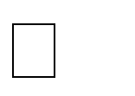

Publication Date: June 26, 2014

Abstract: This patent focuses on analyzing electrical designs, specifically addressing electromigration (EM) reliability in standard cell-based integrated circuit designs. The method estimates failure rates by using a parameterized EM view of the cell along with in-context electrical data.

Claims:

- A method for estimating failure rates in a design containing multiple cell instances by employing an analysis tool and using electrical parameters and a parameterized EM view of the cell.

- Characterizing the standard cell to form a parameterized thermal model and a current model to determine the temperature and current through the cell’s internal structure.

- A non-transitory computer-readable medium storing control logic that enables generation of failure rate estimates from a cell library.

- The method of claim 1, wherein the analysis tool estimates failure rates of interconnects, vias, and devices within the integrated circuit design.

- The method of claim 1, further comprising generating a parameterized current density model and a temperature gradient model for each cell instance to account for electromigration effects.

- The method of claim 1, wherein parameterized thermal and electrical models are created before placement and routing.

- The method of claim 1, further including verifying the design layout to meet electromigration constraints by analyzing the generated electrical and thermal models.

- The method of claim 1, wherein the parameterized EM models are updated dynamically whenever changes are made to the design or fabrication process parameters.

- The method of claim 1, further comprising analyzing different layers of interconnects, including metal layers and vias, to determine failure hotspots caused by electromigration effects.

- A non-transitory computer-readable medium storing instructions that, when executed by a processor, result in generating failure rate estimates for a design by combining electrical parameters, placement constraints, and the parameterized EM views of the standard cells.

Placing Filler Cells in Device Design Based on Layout Aware Electrical Effects[28] Patent Number: US8239799B2
Application Number: US12/774,601 Applicant Name: Freescale Semiconductor, Inc. Country: United States
Inventor Name: David A. Bell

Publication Date: August 7, 2012

Abstract: This patent discusses a method for placing filler cells in an integrated circuit design to mitigate layout-dependent electrical effects. By analyzing standard cells for sensitive features and annotating them with designations, filler cells are strategically placed to prevent adverse interactions between adjacent cells, thereby enhancing device performance and reliability.

Claims:

  - A method comprising:
    - Analyzing a standard cell to identify a sensitive feature within the standard cell layout.
    - Annotating the standard cell with a designation indicating the location of the sensitive feature.
    - Placing a filler cell adjacent to the standard cell based on the designation to mitigate an electrical effect on the sensitive feature.
  - The method of claim 1, wherein the sensitive feature is susceptible to an electrical effect from an adjacent standard cell.

  - The method of claim 1, wherein the filler cell is placed to prevent an aggressor feature of an adjacent standard cell from affecting the sensitive feature.

  - The method of claim 1, further comprising:
    - Determining a physical location for each standard cell in an integrated circuit design based on the designations.

  - The method of claim 1, wherein the designation is a LEF (Library Exchange Format) designation indicating the sensitive feature's location.

  - The method of claim 1, further comprising:
    - Storing the annotated standard cell in a standard cell library.
  - The method of claim 1, wherein the filler cell placement reduces layout-dependent variability in the integrated circuit.

  - The method of claim 1, further comprising:
    - Performing timing analysis on the integrated circuit design considering the filler cell placement.
  - The method of claim 1, wherein the filler cell placement improves manufacturability of the integrated circuit.
  - The method of claim 1, further comprising:
    - Updating the integrated circuit design based on the filler cell placement to enhance performance.

Methods for Double-Patterning-Compliant Standard Cell Design[29] Patent Number: US8907441B2
Application Number: US13/279,146

Applicant Name: Synopsys, Inc.

Country: United States

Inventor Name: Lars W. Liebmann, Andrew B. Kahng

Publication Date: December 9, 2014

Abstract: This patent presents methods for designing standard cells that are compliant with double-patterning lithography requirements. The approach ensures that standard cell layouts are optimized for manufacturing processes that utilize double-patterning techniques, thereby improving yield and performance in advanced technology nodes.

Claims:

- A method comprising:
  - Designing a standard cell layout for an integrated circuit, the layout being compliant with double-patterning lithography requirements.
  - Including the standard cell layout in a cell library for use in integrated circuit design.
- The method of claim 1, wherein the double-patterning lithography requirements include constraints related to feature spacing and coloring.

- The method of claim 1, further comprising:
  - Verifying that the standard cell layout complies with double-patterning requirements using a design rule checking tool.
- The method of claim 1, wherein the standard cell layout includes features designed to minimize patterning errors during fabrication.

- The method of claim 1, further comprising:
  - Modifying existing standard cell layouts in the cell library to comply with double-patterning requirements.
- The method of claim 1, wherein the cell library is used for designing integrated circuits in technology nodes of 45nm and below.

- The method of claim 1, further comprising:
  - Providing the cell library to integrated circuit designers for use in place and route tools.
- The method of claim 1, wherein the standard cell layout is designed to optimize both performance and manufacturability under double-patterning lithography.

- The method of claim 1, further comprising:
  - Simulating the fabrication process to ensure the standard cell layout meets double-patterning requirements.
- The method of claim 1, wherein the standard cell layout includes features that are spaced to comply with the pitch requirements of double-patterning lithography.

CHAPTER IV

METHODOLOGY

Standard Cell Architecture
Standard cell architecture is fundamentally designed around the trade-offs between power, area, and performance, which are critical factors in ASIC design. The initial step in creating a standard cell involves determining the cell height based on pitch and library requirements. Key parameters such as track width, pitch, β ratio, and the widths of PMOS and NMOS transistors must be established, all of which depend on the technology node being utilized. This architecture allows for efficient placement and routing of cells within a chip by standardizing their dimensions, which simplifies the design process and facilitates automatic place and route (APR) tools. The design also enables a systematic approach to optimizing cell performance while managing power consumption and silicon area. As technology nodes shrink, these considerations become increasingly complex, requiring careful balancing to achieve the desired outcomes in modern semiconductor designs.

Track
In semiconductor design, the concept of "track" is crucial for defining the height of standard cells within an ASIC (Application-Specific Integrated Circuit) architecture. A track refers to the vertical space allocated for routing metal layers, and it essentially determines how many routing wires can run in parallel with minimal pitch. For instance, a 12-track library implies that there are 12 routing tracks available, allowing for the simultaneous routing of 12 wires. This results in a taller cell compared to a 9-track library, which offers only 9 tracks.

The height of a standard cell is directly related to the number of tracks it occupies; thus, a higher track count generally allows for more metal routing space within the cell. This increased space can enhance performance, as it facilitates better signal integrity and reduces delays due to shorter interconnects. However, while 12-track cells provide more area and potentially higher speed, they also occupy more silicon real estate compared to 9-track cells, which are more compact but may exhibit lower performance.

The choice between different track libraries depends on design requirements: 7 or 8-track libraries are often used for ultra-high-density and low-power applications, while 9 or 10-track libraries cater to mainstream applications. In contrast, 12-track libraries are preferred for high-performance designs due to their ability to support faster operation. Ultimately, the selection of track height and configuration is a critical decision in standard cell architecture that balances power consumption, performance, and area efficiency.

Pitch
In the context of standard cell architecture, pitch refers to the distance between two adjacent tracks, which is crucial for determining the layout and design of integrated circuits. It defines the spacing necessary for routing metal layers and is a key factor in ensuring that multiple wires can be routed in parallel without interference. For instance, in a standard cell library, a 12-track library indicates that there are 12 routing tracks available, allowing for efficient parallel routing of signals with minimal pitch.

The pitch is calculated based on several parameters, including the width of metal layers, the spacing between them, and any necessary via overhangs. For example, if the metal width is 4 units, the minimum metal-to-metal spacing is 3 units, and the via overhang is 2 units, the pitch can be calculated using the formula:

Pitch = 2 [¹ (metal width) + via overhang] +metal to metal spacing.
2

This calculation ensures that the design adheres to manufacturing rules and avoids design rule check (DRC) errors.

The height of standard cells is typically measured in terms of the number of tracks they occupy. For example, a standard cell that is defined as "6T" would have a height equivalent to six tracks. The selection of pitch directly influences the overall height of standard cells and impacts design density, power distribution, and signal integrity. By maintaining consistent pitch across all cells in a library, designers can facilitate easier placement and routing during the automatic place and route (APR) process, ultimately leading to more efficient chip designs.

Via
In integrated circuit (IC) design, vias are crucial elements used to connect different metal layers within the chip. They serve as vertical interconnects that allow electrical signals and power to travel between layers, facilitating complex routing in multi-layered designs. Vias can be categorized into several types, including contact vias, through vias, blind vias, and buried vias, each serving specific purposes within the circuit architecture.

One important aspect to consider when designing with vias is the via overhang, which refers to the portion of a via that extends beyond the edge of the metal layer it connects. Excessive via overhang can lead to design rule check (DRC) errors, as it may violate spacing requirements between adjacent tracks or other vias. To avoid these errors, designers must ensure that there is adequate spacing between vias and other features on the chip. This involves adhering to specific manufacturing guidelines that dictate minimum spacing and sizing for vias to ensure reliability and performance.

In standard cell architecture, the placement of vias must be carefully planned to optimize signal integrity and minimize parasitic capacitance and resistance. Properly designed vias enable denser packing of components on a chip while maintaining functionality and performance. Overall, vias play a fundamental role in IC design by enabling interconnections between metal layers, supporting complex circuit designs while adhering to stringent manufacturing constraints.

Beta Ratio

The β ratio (beta ratio) in MOSFET design is defined as the ratio of the PMOS width WP to the NMOS width WN, expressed mathematically as:

beta = 𝑃𝑀𝑂𝑆 𝑤𝑖𝑑𝑡ℎ
𝑁𝑀𝑂𝑆 𝑊𝑖𝑑𝑡ℎ

This ratio is critical in CMOS circuit design, particularly for optimizing performance characteristics such as rise and fall delays. To determine an appropriate β ratio, designers often simulate the cell using various MOS widths in a real-time scenario, typically employing a Fan-Out of 3 (FO3) chain configuration. The FO3 chain is advantageous because it effectively mitigates the impact of input slew rates after four to five stages, providing a more stable environment for evaluating the performance of the transistors.

In practice, key cells such as inverters (INV), NOR gates, and NAND gates are analyzed across different MOS widths to derive a reliable β ratio for the entire library. This analysis helps ensure that both PMOS and NMOS transistors can drive equal currents, which is essential for maintaining symmetrical switching characteristics and achieving optimal noise margins.

Importance of the β Ratio
      - Performance Optimization:
The β ratio directly influences the switching performance of CMOS circuits. A well-balanced β ratio ensures that both PMOS and NMOS transistors contribute equally to the output drive strength, resulting in reduced propagation delays and improved overall circuit speed.

      - Current Drive Capability:
Since NMOS devices typically have higher electron mobility compared to PMOS devices (approximately 2-3 times greater), designers often increase the width of PMOS transistors to compensate for this disparity. The β ratio helps achieve a balance in current drive capability between these two types of transistors, ensuring that the circuit can operate effectively under varying load conditions.

      - Impact on Id: The drain current Id of a MOSFET is influenced by its width-to-length ratio W/L. A higher W/L results in increased Id which is essential for driving loads in digital circuits. By adjusting the β ratio, designers can optimize Id for both PMOS and NMOS transistors, enhancing performance while managing power consumption.

      - Threshold Voltage Shifting: Changes in the β ratio can also affect the threshold voltage Vth of inverter circuits. A properly tuned β ratio helps maintain desired voltage levels during switching transitions, contributing to reliable logic levels and reducing susceptibility to noise.
In summary, the β ratio plays a vital role in CMOS design by influencing performance metrics such as delay, current drive capability, and overall circuit reliability. By carefully simulating and adjusting this ratio across various standard cells, designers can create efficient and high-performance integrated circuits.

The β ratio plays a significant role in determining the drain current Id and, consequently, the overall performance of the circuit. The relationship between the β ratio and drain current can be understood through the equations governing MOSFET operation.

Relation of β Ratio to Drain Current

The drain current Id for a MOSFET in linear region can be expressed as:

Id = β (VGS – VTH - Vds) ²
2
The drain current Id for a MOSFET in saturation region can be expressed as:
Id = 1 β (VGS - VTH) ²
2
where:
VGS is the gate-to-source voltage, VTH is the threshold voltage,
VDS is the drain-to-source voltage,

beta is defined as β = µC and oxide capacitance.
^{𝑊} being a process-dependent parameter that includes carrier mobility
𝐿
OX

In this equation, the β ratio directly influences how effectively the gate voltage can control the
drain current. A higher β ratio indicates a wider PMOS relative to NMOS, which can enhance the drive strength of the PMOS transistor, compensating for its lower mobility compared to NMOS. This balance is crucial for achieving symmetrical performance in CMOS circuits.

Impact on Performance

- Transconductance: The transconductance gm which measures how effectively a MOSFET can control the output current based on input voltage changes, is also affected by the β ratio. It can be expressed as:
gm = β (VGS - VTH)
A higher gm leads to better performance in terms of speed and efficiency, allowing faster switching and amplification capabilities in digital circuits.

- Current Drive Capability: The drain current directly impacts how much load the circuit can drive. A properly optimized β ratio ensures that both PMOS and NMOS transistors can deliver sufficient current to meet performance requirements without causing excessive delays.

- Power Consumption: The relationship between drain current and performance also ties into power consumption. By optimizing the β ratio, designers can minimize static power dissipation while maintaining adequate dynamic performance, which is critical in battery-operated devices.

- Noise Margins and Stability: A well-balanced β ratio contributes to improved noise margins in CMOS circuits. This stability is essential for reliable operation across varying temperatures and supply voltages.

In summary, the β ratio significantly influences drain current, which in turn affects key performance metrics such as transconductance, current drive capability, power consumption, and overall circuit stability. Careful optimization of this ratio is essential for achieving high-performance integrated circuits that meet modern design specifications.

Method of Calculation of Beta ratio
To determine the beta ratio for CMOS inverters, NAND gates, and NOR gates, the following structured approach is employed:
- Setting NMOS Width: The process begins by fixing the NMOS width to the minimum width available in the technology provided by the foundry. This ensures that the NMOS transistor operates at its optimal performance characteristics while adhering to design rules.

- Choosing PMOS Width: Next, the PMOS width is selected. The choice of PMOS width is crucial as it directly affects the performance of the inverter and its ability to drive loads.

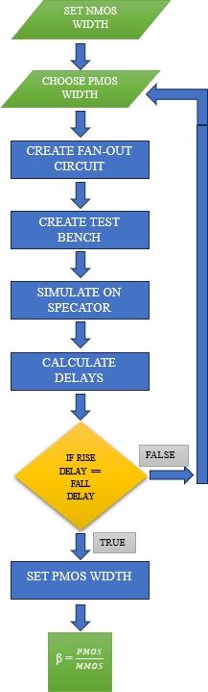
Figure 4.1 Flow diagram to calculate beta ratio

- Creating Inverter Circuit: An inverter circuit is constructed using a schematic editor like Cadence Virtuoso.

- Fan-Out 3 Configuration: To mitigate input slew effects, a Fan-Out of 3 (FO3) configuration is created. This setup helps stabilize input signals and provides a more accurate representation of real-world conditions during simulation.

- Simulation Setup: Simulation parameters are set in the ADEL (Analog Design Environment) window, and the FO3 circuit is simulated using Spectre, a powerful circuit simulator.

- Calculating Rise and Fall Delays: During simulation, both rise delay and fall delay are calculated. It is essential to check if these delays are equal, as achieving equal rise and fall delays minimizes average propagation delay, which enhances circuit performance.

- Adjusting PMOS Width: If the rise and fall delays are not equal, adjustments are made to the PMOS width, and the process is repeated until both delays are equal.

- Calculating Beta Ratio: Once an optimal PMOS width is identified that results in equal rise and fall delays, the beta ratio is calculated using:

beta = 𝑃𝑀𝑂𝑆 𝑤𝑖𝑑𝑡ℎ
𝑁𝑀𝑂𝑆 𝑊𝑖𝑑𝑡ℎ

- Repeating for Other Gates: The same process is then repeated to calculate beta ratios for NAND and NOR gates, ensuring that all standard cells in the library have optimized performance characteristics.

- Performance Analysis: Finally, performance losses for inverters, NAND gates, and NOR gates at different beta ratios are analysed. The goal is to find an optimum beta ratio for the entire library while keeping the inverter as a base reference point. This analysis ensures that NAND and NOR gates exhibit minimal performance loss compared to their ideal operation.

Required Cells
A standard cell library consists of various types of cells that serve specific functions in integrated circuit design. The essential cells typically included in a standard cell library are:
- Basic Logic Gates:
A cell library must be capable of generating any logical expression necessary for the synthesis of a design. This requires a variety of cells with logical functions, such as AND, NAND, XOR, and NOT. However, only a minimal set of these functions is essential for a basic cell library since many functions can be derived from combinations of others. In fact, a standard cell library can fulfill the requirement for all logical expressions using just a NAND cell; similarly, all expressions can also be created using only a NOR cell. Nonetheless, it is often more area-efficient to include multiple logical gates in the library to prevent the place-and-route tools from having to generate them automatically.

- Arithmetic Cells:
Arithmetic cells are crucial components of a standard cell library, enabling the execution of mathematical operations in digital circuits. Key arithmetic cells typically included are half adders, full adders, subtractors, multipliers, and dividers. These pre-designed cells streamline the design process, allowing engineers to implement essential calculations without starting from scratch. By incorporating optimized arithmetic cells, designers can enhance the overall performance of integrated circuits, achieving a balance between speed, area, and power consumption. This optimization is particularly vital in high-performance applications where computational efficiency is critical. Therefore, well-designed arithmetic cells are indispensable for effective digital circuit design.

- Multiplexers:
Multiplexers are critical components in standard cell libraries, functioning as data selectors that route multiple input signals to a single output. They are widely used in digital circuits for applications such as data routing, signal processing, and communication systems. Standard cell libraries typically include multiplexers with varying input configurations, such as 2-to-1, 4-to-1, and 8-to-1 multiplexers, allowing designers to efficiently manage data streams without needing to create these functions from scratch. Incorporating multiplexers into the library enhances design efficiency by optimizing resource utilization and simplifying circuit complexity. Their ability to effectively handle multiple data inputs makes them indispensable in modern electronic systems, contributing significantly to the overall performance of integrated circuits.

- Complex Logic Cells:
Complex logic cells, such as AND-OR-Inverter (AOI) and OR-AND-Inverter (OAI) gates, are essential components of a standard cell library, providing advanced functionality that enhances digital circuit design. These cells enable designers to implement intricate logic functions in a compact form, reducing the number of individual gates needed and optimizing area, speed, and power consumption. By combining multiple logic operations into a single cell, AOI and OAI gates simplify circuit design and improve performance. For example, AOI cells perform both AND and OR operations simultaneously, minimizing propagation delays, while OAI cells offer flexible logic implementation. Their inclusion in the standard cell library supports various applications in modern integrated circuits, making AOI and OAI cells vital for high-performance digital systems and efficient resource utilization.

- Synchronous Cells:
Synchronous cells are vital components of a standard cell library, enabling the creation of essential elements like counters and registers that rely on a clock signal. A key example is the D flip-flop (DFF), which needs to provide complementary outputs and support control signals such as enable, reset, and preset to perform effectively. By

incorporating well-designed synchronous cells like DFFs, designers can streamline the development of reliable digital systems that require precise timing and synchronization, particularly in applications like microprocessors and digital signal processors. Overall, robust synchronous cells are crucial for efficient and effective digital circuit design.

- Buffers:
Buffer cells, including standard buffers, super buffers, and tri-state buffers, are essential components of a standard cell library due to their critical roles in managing signal integrity and timing in digital circuits.

  - Standard buffers amplify signals to ensure they can drive larger loads without distortion, which is particularly important for maintaining signal quality across long interconnects. They help prevent signal degradation and improve overall circuit performance.

  - Super buffers are designed to provide even higher drive strength than standard buffers, making them suitable for driving multiple loads or long distances within a chip. Their enhanced capabilities are crucial in high-performance applications where fast signal transitions are necessary. Super buffers typically come in two configurations: inverting super buffers, which invert the input signal for improved performance, and non-inverting super buffers, which maintain the same logic level at the output as the input, reinforcing signals without inversion.

  - Tri-state buffers add an additional layer of functionality by allowing the output to be in one of three states: high, low, or high impedance (Z). This capability is vital for bus systems where multiple devices share a common data line, as it prevents conflicts when multiple outputs attempt to drive the bus simultaneously.

Incorporating these buffer types into a standard cell library enhances design flexibility and efficiency, enabling designers to optimize performance based on specific application requirements. Overall, buffer cells are indispensable for ensuring reliable communication within complex digital systems.

- Physical Only Cells:
Physical only cells are specialized components in a standard cell library that do not have logical functionality but play critical roles in the physical design of integrated circuits. These cells include well tap cells, decoupling capacitor (decap) cells, end cap cells, filler cells and tie cells.

  - Well tap cells are used to connect n-well and p-well regions to the appropriate power and ground rails, ensuring proper biasing of transistors. They help prevent latch-up issues by maintaining low resistance paths between the substrate and

power rails, which is essential for reliable circuit operation. In modern designs, libraries may utilize "tap-less" configurations where well taps are not included in every cell, instead relying on strategically placed well tap cells to meet design rules regarding spacing.

  - Decap cells function as charge reservoirs, providing additional capacitance between power and ground rails. They are crucial during high current demand periods, helping to stabilize the voltage supply by compensating for IR drops that occur due to resistance in the power distribution network. This capability enhances noise margins and overall circuit reliability.

  - End cap cells, also known as boundary cells, are placed at the edges of standard cell rows to protect the gates of adjacent cells from potential damage during manufacturing. They help ensure proper alignment and integration of different chip sections while preventing design rule check (DRC) violations. These cells typically consist of n-well layers, implant layers, and dummy poly layers, and they may also include decoupling capacitors to enhance power stability.

  - Filler cells are used to fill gaps in the layout between standard cells, ensuring that the design meets manufacturing requirements and maintains structural integrity. They help achieve a uniform distribution of materials across the chip, which is important for both thermal management and mechanical stability.

  - Tie cells are used to connect well regions to power or ground rails, ensuring that the n-well and p-well are properly biased. This connection is vital for preventing latch-up conditions and ensuring reliable operation of transistors located near the chip boundaries. Tie cells help maintain the integrity of the well structure throughout the chip.

Incorporating these physical only cells into a standard cell library enhances design flexibility and compliance with manufacturing constraints, ultimately contributing to the performance and reliability of integrated circuits.

- Scannable Flip-Flops:
Scannable flip-flops are specialized flip-flops designed to support testing and debugging of sequential circuits in integrated circuit (IC) designs. They enable the implementation of scan chains, a key technique in Design for Testability (DFT). In a standard cell library, scannable flip-flops incorporate multiplexers that allow switching between normal operation and scan mode. When the Scan Enable (SE) signal is low, they function normally, capturing data from combinational logic. When SE is high, the flip-flops form a scan chain, allowing test patterns to be shifted in and out of the circuit, which is essential for fault detection and ensuring reliability in complex digital systems. Their

inclusion in a standard cell library enhances testing efficiency, enabling designers to identify and troubleshoot issues during manufacturing, thus improving the overall quality and performance of integrated circuits.

While only a few cells are technically required to create a complete standard cell library, a more extensive selection is necessary for practical usability. To enhance flexibility and optimize designs, it is important to develop multiple versions of each cell with varying sizes, speeds, loads, and driving strengths. Although a simple NAND cell can generate logical expressions, using a custom-made AND cell is often more efficient than connecting several NAND cells to achieve the same function, as this can improve both area and speed. This raises questions about the optimal number of cells needed in a library. Research by Nguyen Minh Duc and Takayasu Sakurai has indicated that a well-chosen library of around 20 cells can result in only 2% more delay compared to a larger library of 400 cells. A smaller number of cells not only reduces synthesis time but also shortens development time, making it clear that an efficient balance between the number of cells and their performance benefits is crucial in standard cell library design.

Content of Cells
The cell library comprises a variety of different cells, each of which is associated with several essential files. Below is a list of these files along with a brief description of their purpose, which are required for each cell in a standard cell library.
- Schemtic:
The schematic serves as a high-level representation of a design, similar to the layout, but it uses symbols to represent transistors and wiring. It is essential for generating the Timing Library Format (TLF) file for the cell library. The schematic must be imported into Aptivia, the tool used for creating TLF files, and it can also be beneficial for performing Layout Versus Schematic (LVS) checks. While the schematics that describe the cells need to be created manually, those representing the desired construction can be automatically generated by importing a Verilog netlist produced by the synthesis tool.

- A netlist is a crucial representation in electronic design that describes the connectivity of an electronic circuit, detailing how components like transistors, resistors, and capacitors are interconnected. It serves as an intermediary between schematic designs and physical layouts, facilitating various stages of hardware development, including simulation, logical synthesis, and physical layout generation. Netlists can be generated in several formats, including SPICE files for detailed circuit simulation, Spectre files for analog and mixed-signal circuit analysis in Cadence environments, EDIF (Electronic Design Interchange Format) for exchanging netlists between different electronic design automation (EDA) tools, and IPC-356 for describing electrical connections in PCB design. By utilizing these formats, designers can ensure compatibility with various EDA

tools and perform accurate timing analysis to identify potential issues related to signal delays and timing violations before fabrication.

- Layout:
The layout file contains the physical representation of a design, detailing the placement of transistors, wiring, and other components. This digital layout reflects what will be physically implemented on a chip. It is essential for generating the Library Exchange Format (LEF) file and creating an abstract representation of the design. Additionally, certain specific constraints must be met beyond those required for a standard layout. The layout must undergo various verification checks, including Design Rule Checking (DRC) and Layout Versus Schematic (LVS), to ensure compliance with manufacturing standards before it can be sent to a semiconductor foundry for fabrication.

- Extracted View:
The extracted view is a vital representation in integrated circuit design that includes parasitic elements from the physical layout, such as capacitances, resistances, and inductances. This view is essential for simulating the circuit's performance, as it reflects how the circuit will behave under real-world conditions. By using the extracted view during simulation, designers can identify potential issues related to signal integrity, timing delays, and power consumption before fabrication. The extracted view is commonly used in tools like Cadence's Quantus Smart View for post-layout verification and debugging. It ensures that simulations account for all relevant parasitic effects, leading to more reliable predictions of circuit behaviour. This capability is crucial for optimizing designs and ensuring they meet performance specifications in advanced semiconductor technologies.

- Abstract View:
The abstract serves as a simplified representation of the layout in integrated circuit design. Generated by an abstract generator, the abstract file is crucial for the place and route process, as it is used instead of the full layout. This file contains only the layers necessary for interconnections, hiding the detailed content of the cell to simplify the design and avoid cloning issues. The abstract view is similar to the layout view but focuses on essential elements that facilitate automated placement and routing. Additionally, it is from the abstract views that the Library Exchange Format (LEF) file is generated, further streamlining the design process.

- Symbol:
The symbol view is a simplified graphical representation of an integrated circuit (IC) that illustrates its functional aspects using schematic symbols. It is essential for creating circuit schematics, allowing designers to visualize component interactions without detailing the physical layout. Used in electronic design automation (EDA) tools, the

symbol view ensures accurate pin naming and arrangement, which are crucial for avoiding incorrect connections. It is particularly helpful in the early design stages for creating and modifying circuit diagrams and generating netlists for simulation and synthesis. Overall, the symbol view is a fundamental element in the IC design process, facilitating efficient design practices and enhancing collaboration among engineers.

- Verilog:
A Verilog file is a text file containing code written in the Verilog hardware description language (HDL), used for modeling and designing digital circuits at various abstraction levels, including register-transfer level (RTL) and gate level. These files serve multiple purposes: they define circuit functionality, enable simulation to verify design correctness before physical implementation, allow synthesizable code to be converted into a gate-level netlist for fabrication, and facilitate the creation of testbenches for validating designs through various input scenarios. Overall, Verilog files are essential in the design, verification, and implementation processes of digital circuits, promoting efficient development and ensuring high-quality outcomes in integrated circuit production.

- LEF File:
LEF, or Library Exchange Format, is a specification used to represent the physical layout information of integrated circuits in an ASCII format. There are two types of LEF files, Technology LEF and Macro (Cell) LEF. The Technology LEF contains details about metal layers, vias, and design rules necessary for fabrication, while the Macro LEF provides information about standard cells, including their geometry, pin locations, and usage. The Technology LEF is used to generate the Macro LEF, which is essential for tools like PKS (Physically Knowledgeable Synthesis) and SEULTRA during the place and route process. LEF files enable efficient design by providing an abstract view of the layout, which helps save memory and resources while ensuring that the necessary information for routing and placement is readily available.

Development of Standard Cell Library:
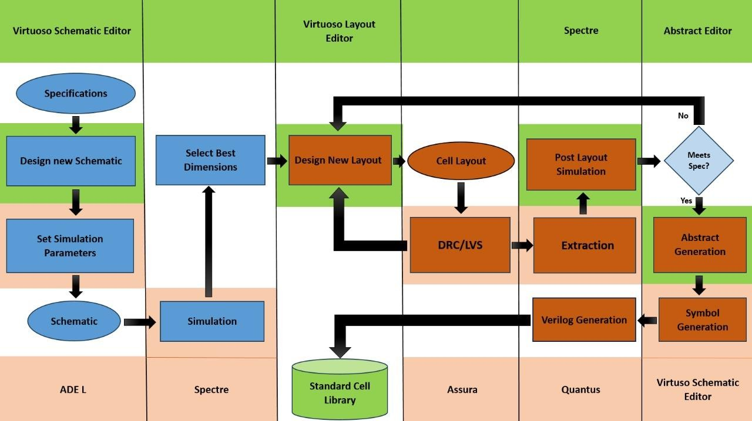
Figure 4.2 Block Diagram and tools need to develop Standard cell

The block diagram outlines the methodology and tools required to develop a single cell using the Cadence tool suite, specifically focusing on the design and simulation of integrated circuits. Below is a detailed explanation of each component and its role in the process:

- Specifications
The design process begins with acquiring specifications from the vendor or foundry. These specifications include critical parameters such as the technology node, design goals (e.g., low power, low area, high performance), the number of tracks available for routing, and other essential information. Clear specifications guide the entire design process, ensuring that the final product meets the intended performance and manufacturability requirements.

- Virtuoso Schematic Editor
This tool is used to create the initial circuit schematic. Designers can place and connect various components such as transistors, resistors, capacitors, and other elements necessary for the cell design. The accuracy of the schematic is crucial, as it serves as the foundation for all subsequent design and simulation activities. Any errors at this stage can lead to significant issues later in the process.

- Set Simulation Parameters
Designers configure simulation parameters such as supply voltage, temperature, load conditions, and input signals in preparation for running simulations. Correctly setting these parameters is essential for obtaining realistic results that reflect actual operating scenarios. This ensures that simulations provide valuable insights into circuit behavior.

- Spectre Simulation
Spectre is a powerful circuit simulator used to analyze the behavior of the designed circuit under various conditions. It allows for transient, AC, DC, and noise analysis. Simulation helps verify that the circuit operates correctly before fabrication, identifying potential issues early in the design process. This step is critical for ensuring reliability and functionality.

- Select Best Dimensions
This step involves optimizing component sizes (like transistor widths) to achieve desired performance metrics such as speed, power consumption, and area efficiency. Optimization is critical to ensure that the design meets specifications while minimizing resource usage. Proper sizing can significantly impact overall circuit performance.

- Design New Layout
After finalizing the schematic, this step involves creating the physical layout of the circuit using tools like Virtuoso Layout Editor. The layout defines how components are arranged on the silicon chip. Proper layout design ensures compliance with manufacturing rules and optimizes performance characteristics like area and power consumption. A well-designed layout is essential for successful fabrication.

- Assura
Assura is a verification tool used for checking physical layouts against design rules (DRC) and ensuring that layouts meet electrical specifications (LVS). Physical verification is crucial to ensure that designs are manufacturable and function correctly without errors. This step helps catch potential issues before fabrication.

- Extraction
This step uses Quantus to extract parasitic resistors and capacitors from the layout based on settings chosen in Quantus. Parasitic elements can significantly impact circuit performance; thus, accurate extraction is vital for reliable post-layout simulations.

- Post Layout Simulation
This involves simulating the circuit after layout to account for parasitic effects introduced by routing and component placement. Post-layout simulations provide a more accurate representation of how the circuit will perform in real-world conditions.

If specifications are not met during this simulation stage, adjustments must be made to the layout.

- Abstract Generation
After completing the layout, an abstract view may be generated using an Abstract Editor for use in higher-level design tools or documentation purposes. Abstracts simplify complex designs into a more manageable format for integration into larger systems or for communication with other designers.

- Verilog Generation
This refers to generating Verilog code from the schematic or layout for digital simulations or synthesis. Verilog code is essential for digital design verification and can be utilized in various simulation environments, facilitating further testing and integration into larger designs.
This block diagram provides a comprehensive overview of the structured approach taken when developing a single cell using Cadence's tool suite. Each component plays a vital role in ensuring that the final product meets performance specifications while adhering to manufacturing constraints. By following this methodology, designers can effectively manage complexity and enhance their designs' reliability and efficiency throughout the IC development process.

Sequential Cells

Sequential cells are fundamental components in digital circuits, especially within standard cell libraries used in ASIC (Application-Specific Integrated Circuit) design. These cells include memory elements such as flip-flops and latches, which store information and maintain state over time. The importance of sequential cells lies in their ability to remember past inputs, allowing them to produce outputs that depend not only on current inputs but also on previous states. This characteristic enables the implementation of complex functionalities like counters, shift registers, and finite state machines, which are essential for various applications in computing and digital communication.

Characterization of sequential cells involves determining their performance metrics, such as timing, power consumption, and area. This process typically includes simulations that assess how these cells behave under different conditions, including varying input patterns and operating frequencies. The results of characterization provide critical data that designers use to optimize circuit performance and ensure reliable operation within the overall design context. For instance, timing characterization helps identify setup and hold times, which are crucial for ensuring that data is correctly latched before the next clock edge.
Moreover, accurate characterization allows for better integration of sequential cells into larger designs by providing standardized parameters that can be used during synthesis and place-and-

route processes. As technology nodes shrink, the complexity of sequential circuits increases, making robust characterization even more vital. In summary, sequential cells play a crucial role in digital design by enabling memory functions and complex logic operations, while their characterization is essential for optimizing performance and ensuring reliability in integrated circuits.

Delay Characterization for Sequential Cell

    - Timing Parameters in a Sequential Cell Setup time:
Setup time is defined as the minimum amount of time before the clock's active edge that the data must be stable for it to be latched correctly. In other words, each flip-flop (or any sequential element, in general) needs some time for the data to remain stable before the clock edge arrives, such that it can reliably capture the data. This duration is known as setup time.
The data that was launched at the previous clock edge should be stable at the input at least setup time before the clock edge. So, adherence to setup time ensures that the data launched at previous edge is captured properly at the current edge. In other words, we can also say that setup time adherence ensures that the system moves to next state smoothly.
Hold time:
Hold time is defined as the minimum amount of time after the clock's active edge during which data must be stable. Similar to setup time, each sequential element needs some time for data to remain stable after clock edge arrives to reliably capture data. This duration is known as hold time.
The data that was launched at the current edge should not travel to the capturing flop before hold time has passed after the clock edge. Adherence to hold time ensures that the data launched at current clock edge does not get captured at the same edge. In other words, hold time adherence ensures that system does not deviate from the current state and go into an invalid state.

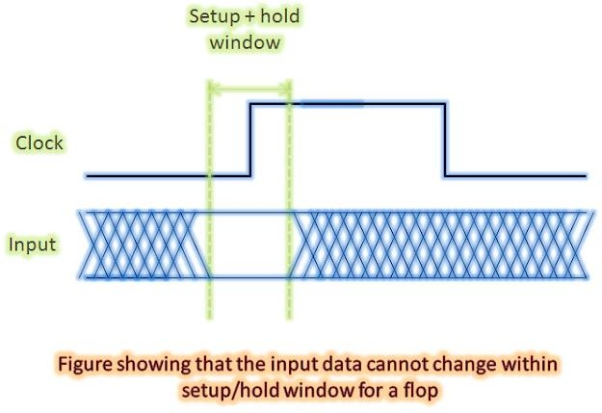
Figure 4.3 Setup and Hold Window

Cause/origin of setup time and hold time
Setup time and hold time are said to be the backbone of timing analysis. Rightly so, for the chip to function properly, setup and hold timing constraints need to be met properly for each and every flip-flop in the design. If even a single flop exists that does not meet setup and hold requirements for timing paths starting from/ending at it, the design will fail and meta-stability will occur. It is very important to understand the origin of setup time and hold time as whole design functionality is ensured by these. Let us discuss the origin of setup time and hold time taking an example of D-flip-flop as in VLSI designs, D-type flip-flops are almost always used. A D-type flip-flop is realized using two D-type latches; one of them is positive level-sensitive, the other is negative level-sensitive. A D-type latch, in turn, is realized using transmission gates and inverters. Figure below shows a positive-level sensitive D-type latch. Just inverting the transmission gates’ clock, we get negative-level sensitive D-type latch.

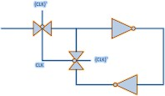
Figure 4.4 D-type latch

A complete D flip-flop using the above structure of D-type latch is shown in figure below:
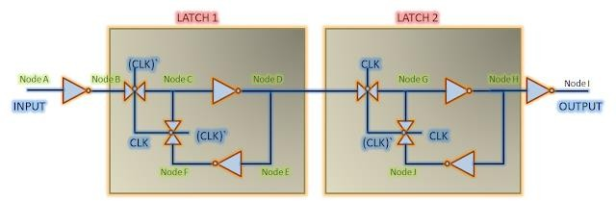

Figure 4.5 D-Flip Flop

Now, let us get into the details of above figure. For data to be latched by ‘latch 1’ at the falling edge of the clock, it must be present at ‘Node F’ at that time. Since, data has to travel ‘NodeA’
-> ‘Node B’ -> ‘Node C’ -> ‘Node D’ -> ‘Node E’ -> ‘Node F’ to reach ‘Node F’, it should arrive at flip-flop’s input (Node A) at some earlier time. This time for data to reach from ‘Node A’ to ‘Node F’ is termed as data setup time (assuming CLK and CLK' are present instantaneously. If that is not the case, it will be accounted for accordingly). Similarly, it is necessary to ensure a stable value at the input to ensure a stable value at ‘Node C’. In other words, hold time can be termed as delay taken by data from ‘Node A’ to ‘Node C’.
In other words, mathematically speaking, setup check equation is given as below (assuming zero skew between launch and capture clocks):

Tck->q + Tprop + Tsetup < Tperiod

Similarly, hold check equation is given as:
Tck->q + Tprop > Thold

If we consider skews between the two clocks, the above equations are modified accordingly. If Tskew is the skew between launch and capture flops, (equal to latency of clock at capture flop minus latency of clock at launch flop so that skew is positive if capture flop has larger latency and vice-versa), above equations are modified as below: [32]

Tck->q + Tprop + Tsetup - Tskew < Tperiod Tck->q + Tprop > Thold + Tskew

Methodology for Finding the Sequential Delays of a Standard Cell
With combinational element concerned only with the propagation delay of the cell, the sequential element are bit more complex in this scenario. With different arcs it is necessary to model setup time, hold time and c-q delay of a flop while modeling it into the library. The number of arcs required to model can vary within the sequential elements. In this paper we will be discussing about the methodology to find the setup time, hold time or C-Q delay of flip-flops and latches. The min pulse width requirements as discussed in the previous section are a derivative of setup and hold time itself and hence will be implicitly covered. []
Setup time for Flip Flop:
- Take a clock of pulse width 10ns i.e. a frequency of 100MHz
- Consider data transition from 0 → 1 at infinite setup time say 10ns before the active clock edge.
- Calculate the C-Q delay from 50% of clock to 50% of Output.
- Keep on bringing the data closer to the active edge of the clock.
- Calculate the C-Q delay for each input vector and check for 10% increase in C-Q delay.
- Note the difference of transition time between data input and the clock active edge.
- This will become the setup time of the flop.

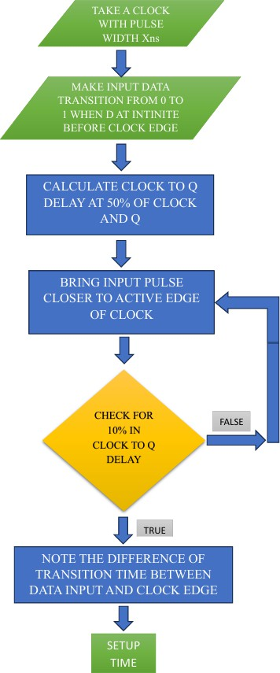

Figure 4.6 Flow diagram to calculate Setup time
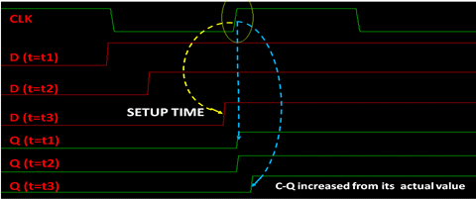
Figure 4.7 Setup timing measurement for a positive edge triggered flip-flop

Hold Time for Flip Flop:
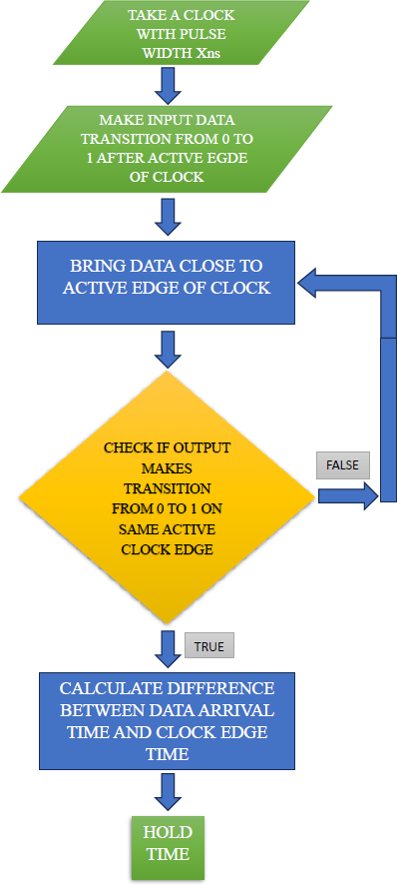
Figure 4.8 Flow diagram to calculate Hold time
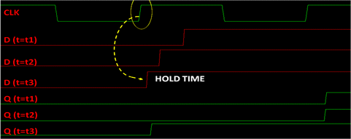
Figure 4.9 Hold timing measurement for a positive edge triggered flip-flop

- Take a clock of pulse width 10ns i.e. a frequency of 100MHz
- Consider data transition from 0 → 1 at infinite setup time say 10ns before the active clock edge.
- Keep on bringing the data closer to the active edge of the clock.
- Time when the output makes a transition from 0→1, calculate the difference between the data arrival time and clock edge time that will give the hold time for the flip flop.

Clock to Out (C-Q) Delay
Clock to out delay is generally considered at infinite setup time. With data making a transition at 10ns before the active clock edge, one can probe the two signals clock and output both at 50% of their voltage levels. The difference between their transitions will give the clock to out or C-Q delay for the flip flop.

Min Pulse Width
Min pulse width is defined as the minimum permissible pulse width values for both high and low levels below which a given sequential element like flip-flop, latch or SRAM cell will fail to work. It signifies the minimum time these cells will take to function and provide the correct output while being operated. For simulation purposes it is simply another form of representing set44up and hold time corresponding to the concerned clock edge and hence can be characterized for different output loads, input slews and triggering events similar to setup and hold time. Figure 3, shows how high and low min pulse width requirements can be modeled based on flop/latch setup and time. [34]
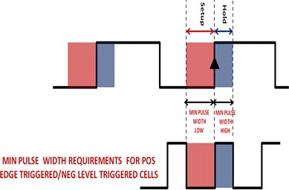

Figure 4.10 Min Pulse Width and its relationship with setup and hold time

What if setup and/or hold violations occur in a design
As said earlier, setup and hold timings are to be met in order to ensure that data launched from one flop is captured properly at the next flop at next clock edge so as to transfer the state-machine of the design to the next state. If the setup check is violated, the data will not be captured at the next clock edge properly. Similarly, if hold check is violated, data intended to be captured at the next edge will get captured at the same edge. Setup hold violations can also lead to data changing within setup/hold window of the capturing flip-flop. It may lead to metastability failure in the design. So, it is necessary to have setup and hold requirements met for all the flip-flops in the design and there should not be any setup/hold violation. [32]

Tackling setup time violation:
As given above, the equation for setup timing check is given as:

Tck->q + Tprop + Tsetup - Tskew < Tperiod

The parameter that represents if there is a setup time violation is setup slack. The setup slack can be defined as the difference between the L.H.S and R.H.S. In other words, it is the margin that is available such that the timing path meets setup check. The setup slack equation can be given

Setup slack = Tperiod - (Tck->q + Tprop + Tsetup - Tskew)

If setup slack is positive, it means there is still some margin available in the timing path. On the other hand, a negative slack means that the paths violates setup timing check by the amount of setup slack. To get the path met, either data delay should be decreased or clock period should be increased.

Mitigating setup violation: Thus, we can meet the setup requirement, if violating, by
      - Decreasing clk->q delay of launching flop
      - Decreasing the propagation delay of the combinational cloud
      - Reducing the setup time requirement of capturing flop
      - Increasing the skew between capture and launch clocks
      - Increasing the clock period

Tackling hold time violation
Similarly, the equation for hold timing check is as below:
Tck->q + Tprop > Thold + Tskew

The parameter that represents if there is a hold timing violation is hold slack. The hold slack is defined as the amount by which L.H.S is greater than R.H.S. In other words, it is the margin by which timing path meets the hold timing check. The equation for hold slack is given as: Hold slack = Tck->q + Tprop - Thold - Tskew If hold slack is positive, it means there is still some margin available before it will start violating for hold. A negative hold slack means the path is violating hold timing check by the amount represented by hold slack. To get the path met, either data path delay should be increased, or clock skew/hold requirement of capturing flop should be decreased.

Mitigating hold violation:
We can meet the hold requirement by:
- Increasing clk->q delay of launching flop.
- Decreasing the hold time requirement of capturing flop.
- Decreasing the skew between capture and launch clocks. [32]

Metastability

Metastability is a phenomenon of unstable equilibrium in digital electronics in which the sequential element is not able to resolve the state of the input signal; hence, the output goes into unresolved state for an unbounded interval of time. Almost always, this happens when data transitions very close to active edge of the clock, hence, violating setup and hold requirements. Since, data makes transition close to active edge of clock, the flop is not able to capture the data completely. The flop starts to capture the data and output also starts to transition. But, before output has changed its state, the input is cut-off from the output as clock edge has arrived. The output is, then, left hanging between state ‘0’ and state ‘1’. Theoretically, the output may remain in this state for an indefinite period of time. But, given the time to settle down, the output will eventually settle to either its previous state or the new state. Thus, the effect of signal present at input of flop may not travel to the output of the flop partly or completely. In other words, we can say that when a flip-flop enters metastable state, one cannot predict its output voltage level after it exits the metastability state nor when the output will settle to some stable voltage level. The metastability failure is said to have occurred if the output has not resolved itself by the time it must be available for use. Also, since, the output remains in-between ‘0’ and ‘1’, which means both P-MOS and N-MOS are not switched off. Hence, VDD is shorted to GND terminal making it cause a high current to flow through as long as the output is hanging in-between. [33]

CHAPTER V
RESULTS AND DISCUSSIONS

Standard cell Architecture
To calculate the pitch and standard cell height for a standard cell library with 12 tracks in a 45nm technology node, we utilize specific parameters set by the foundry. These parameters are crucial for ensuring that the design adheres to manufacturing specifications and optimizes layout efficiency.

Given Parameters for 45nm Technology Node:
Metal Width: 0.06 µm
Minimum Metal to Metal Spacing: 0.06 µm Via Overhang: 0.02 µm
Number of Tracks: 12

Calculation of Pitch

The formula for calculating pitch is:
Pitch = 2 [¹ (metal width) + via overhang] +metal to metal spacing
2
Substituting the values:
Pitch = 2 [¹ (0.06) + 0.02] + 0.06
2
= 2 [0.03 + 0.02] + 0.06
= 0.10 + 0.06
= 0.16
Thus, the Pitch is 0.16 µm.

Calculation of Standard Cell Height

The formula for standard cell height is:
Standard Cell Height = Pitch * (N - 1) Substituting the values:
Standard Cell Height = 0.16 * (12 - 1)
= 0.16 * 11
= 1.76
Thus, the Standard Cell Height = 1.76 µm.
These calculations provide essential dimensions for designing a standard cell library in a 45nm technology node, ensuring compliance with design rules and optimizing layout efficiency.

Beta Ratio Analysis
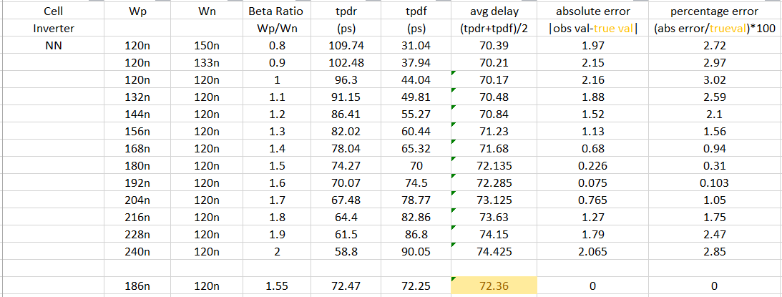
The following tables present the delay analysis for various beta ratios in inverters, NAND gates, and NOR gates.

Table 5.1 Delay analysis of Inverter

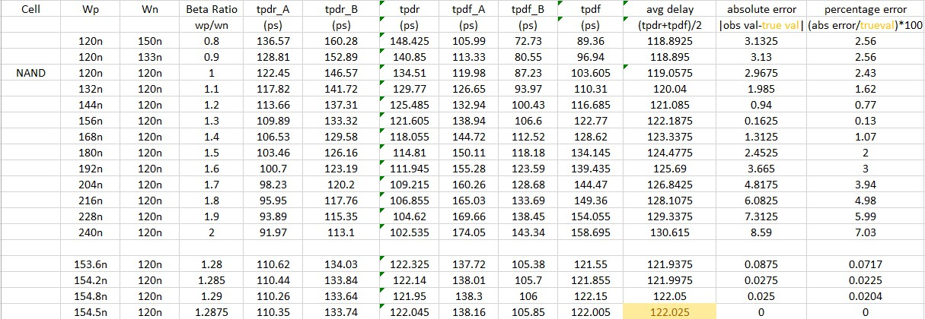
Table 5.2 Delay Analysis of NAND gate
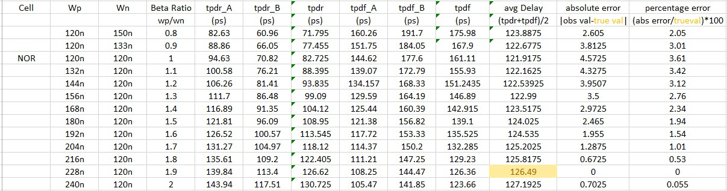
Table 5.3 Delay Analysis of NOR gate

The comparative analysis of performance loss for inverters, NAND gates, and NOR gates at different beta ratios is summarized in the table below, based on the previously mentioned tables.

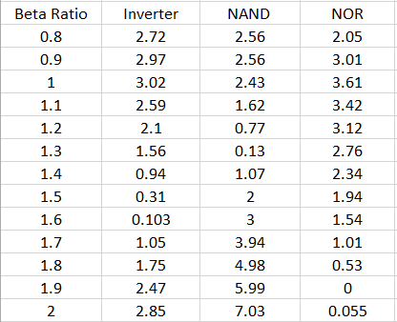
Table 5.4 Comparative Delay analysis at different beta ratios

The data from the above table can be visualized graphically as shown below.
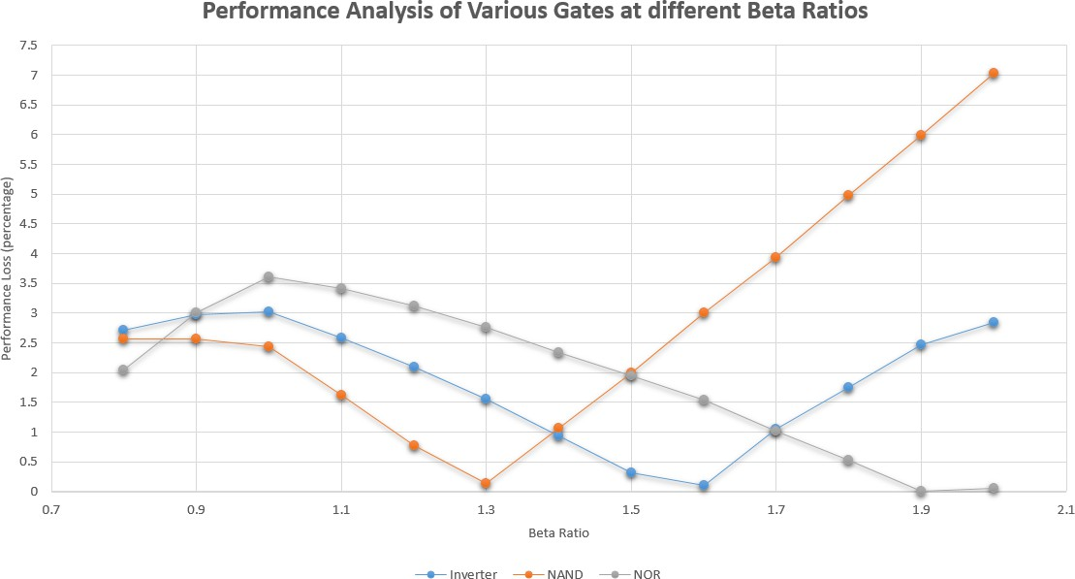

Figure 5.1 Performance Analysis of Various gates at different Beta ratios

The analysis of beta ratios across various logic cells, specifically inverters, NAND gates, and NOR gates. Below are the key findings and discussions derived from the beta ratio analysis:

Each logic cell exhibits a unique beta ratio at which its performance loss remains negligible. By calculating the beta ratios for all cells, we can identify the optimal settings that minimize delays and power consumption while maintaining functionality.

After evaluating the individual beta ratios, we assess the performance trade-offs to determine a single beta ratio suitable for the entire library. This is crucial for ensuring that all cells operate efficiently under varying conditions.

For this library, the beta ratio is fixed at 1.5. This choice results in a performance loss trade-off of 2% for NAND gates and 1.94% for NOR gates. The relationship between PMOS and NMOS widths is established as:

WP = 1.5 *WN
This configuration balances performance across different gate types while keeping losses within acceptable limits.

PVT Analysis of Inverter
The PVT (Process-Voltage-Temperature) analysis of the inverter at different corners is summarized in the tables below. This analysis evaluates the performance of the inverter under varying conditions, ensuring that it meets design specifications across a range of operating environments.
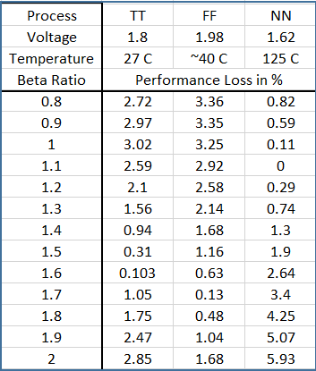
Table 5.5 Performance analysis of inverter at different PVT

      - Typical (TT) Process:
        - Voltage: 1.8V VDD

        - Temperature: 27°C
        - Beta Ratio: 1.55
        - Performance Loss: Negligible

      - Fast-Fast (FF) Process:
        - Temperature: -40°C
        - Voltage: Exceeding 10% of 1.8V VDD
        - Beta Ratio: 1.73
        - Performance Loss: Negligible

      - Slow-Slow (SS) Process:
        - Temperature: 125°C
        - Voltage: Below 10% of VDD
        - Beta Ratio: 1.1
        - Performance Loss: Negligible

Overall Library Performance
The above table can be visualized graphically as follows
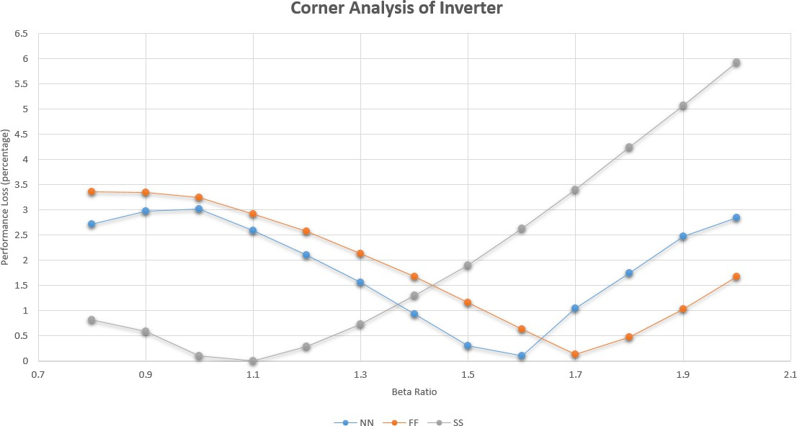
Figure 5.2 Performance Analysis of Inverter at different PVT corners

With a library-wide beta ratio fixed at 1.5, the performance loss is calculated as follows: For the fast process (FF): 1.16%

For the slow process (SS): 1.9%

These results indicate that the library operates robustly across a temperature range from -40°C to 125°C, with permissible voltage variations from 1.62V to 1.98V.

The PVT analysis demonstrates that the inverter maintains acceptable performance levels under various conditions, ensuring reliability and functionality in real-world applications. The selected beta ratios for different processes optimize performance while minimizing losses, making the standard cell library suitable for modern ASIC designs.

The total cells present in our library are listed as shown in figure
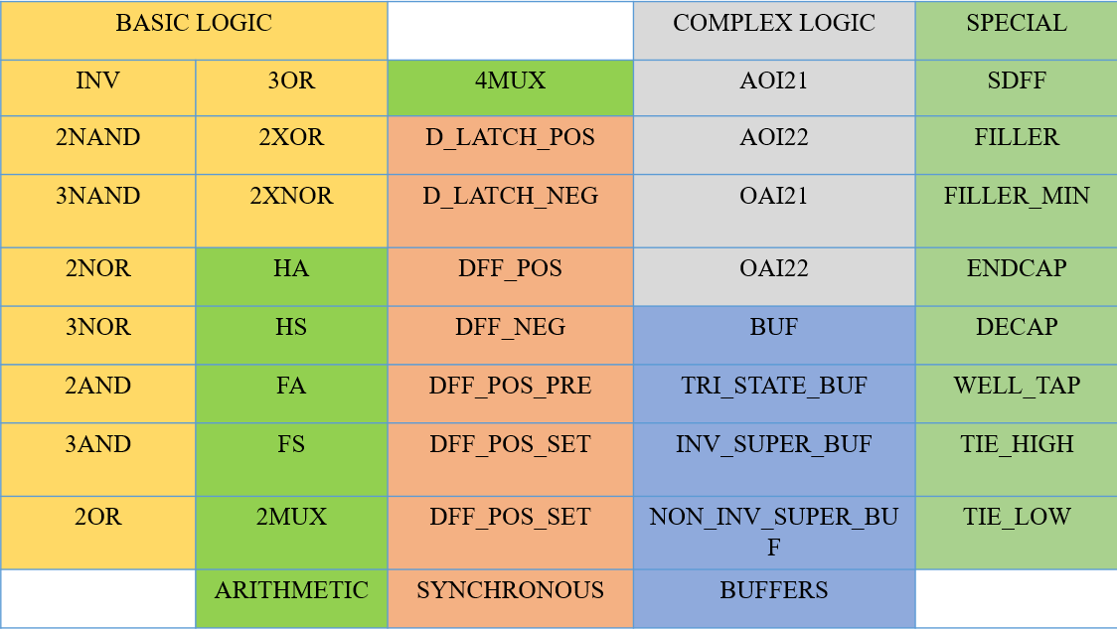

Figure 5.3 Cells in Library

Setup Time and Hold time Analysis
Figure 5.4 Setup time with clock input
Setup time with clock input
1.21E-08
1.20E-08
1.19E-08
1.18E-08
1.17E-08
1.16E-08
1.15E-08
1.20E-08
1.00E-08
8.00E-09
6.00E-09
4.00E-09
2.00E-09
0.00E+00
1 3 5 7 9 11 13 15 17 19 21 23 25 27 29 31 33 35 37 39
Delay (s)
rd (s)
The setup and hold times of a D flip-flop were analysed using a direct clock input signal connected to the data input.

Setup Time Analysis:

  - The setup time was calculated as 41.9 ps.
  - The delay (blue bars) increases as the clock edge approaches, with a sharp rise observed when the setup time is violated, leading to unreliable latching.

Hold Time Analysis:

  - The hold time was measured to be 0 ps, indicating that data remains stable immediately after the clock edge, ensuring proper functionality.

These results underline the importance of adhering to setup time requirements during circuit design. The 0 ps hold time is a significant advantage, enabling more flexible design margins. However, ensuring that the setup time is not violated is crucial to prevent data loss or incorrect operation.

Setup time for clk after 2 inv
1.20E-08
1.20E-08
1.20E-08
1.20E-08
1.20E-08
1.20E-08
1.20E-08
1.20E-08
1.20E-08
1.20E-08
1.60E-11
1.40E-11
1.20E-11
1.00E-11
8.00E-12
6.00E-12
4.00E-12
2.00E-12
0.00E+00
1 3 5 7 9 11 13 15 17 19 21 23 25 27 29 31 33 35 37 39
Delay (s)
rd (s)
Figure 5.5 Setup time for clock after 2 Invertes
Hold time for clk after 2 inv
1.20E-08
1.20E-08
1.20E-08
1.20E-08
1.20E-08
1.20E-08
1.20E-08
1.20E-08
1.20E-08
1.20E-08
1.20E-08
1.00E-08
8.00E-09
6.00E-09
4.00E-09
2.00E-09
0.00E+00
1 2 3 4 5 6 7 8 9 10 11 12 13 14 15 16 17 18 19 20
Delay (ns)
rd (ps)
Figure 5.6 Hold time for clock after 2 inverter

The setup and hold times of a D flip-flop were analysed using a clock input signal after 2 inverters connected to the data input and clock bar signal given after 3 inverters.

Setup Time Analysis:
  - The setup time was calculated as 10.8ps

Hold Time Analysis:
  - The hold time was measured to be 0.26 ps

The current results show a marked improvement in setup time, which is beneficial for faster operation. However, the slight increase in hold time (from 0 ps to 0.26 ps) is negligible and unlikely to impact overall performance negatively. This trade-off between setup and hold times reflects design optimizations aimed at balancing timing constraints for high-speed systems.

The Setup time was then analysed for a D flip-flop by increasing the input slew of CLOCK signal and INPUT DATA. (0.2ns to 2ns).
Setup time for Increased slew of Input and clock pulse
1.14E-08
1.13E-08
1.13E-08
1.12E-08
1.12E-08
1.11E-08
1.11E-08
1.10E-08
1.10E-08
1.09E-08
3.60E-11
3.50E-11
3.40E-11
3.30E-11
3.20E-11
3.10E-11
3.00E-11
2.90E-11
2.80E-11
2.70E-11
2.60E-11
1 3 5 7 9 11 13 15 17 19 21 23 25 27 29 31 33 35 37 39
Delay (s)
rd (s)
Figure 5.7 Setup time for increased slew of Input and clock pulse

Setup Time Analysis:
  - The setup time was calculated as 850ps

The comparison illustrates how sensitive setup time is to signal slew rates. While the earlier designs demonstrated high performance, the dramatic increase to 850 ps highlights the potential for timing violations in circuits with slower signal transitions. These findings underline the necessity of careful signal integrity management, especially in high-speed or dense integrated circuits.

The Setup time was again analysed for a D flip-flop by increasing only the input slew of CLOCK signal (0.2ns to 2ns).
Setup time for Increased slew of Input and clock pulse
1.14E-08
1.13E-08
1.12E-08
1.11E-08
1.10E-08
1.09E-08
3.60E-11
3.40E-11
3.20E-11
3.00E-11
2.80E-11
2.60E-11
1 3 5 7 9 11 13 15 17 19 21 23 25 27 29 31 33 35 37 39
Delay (s)
rd (s)
Figure 5.8 Setup time for increased slew of Input and clock pulse

Setup Time Analysis:
  - The setup time was calculated as 1.18ns

A slower clock slew significantly impacts the setup time, making it unsuitable for high-speed designs. This emphasizes the need for careful clock signal design, particularly in high-speed circuits, to avoid timing violations caused by increased setup times.

PVT Analysis of Setup time
- Process Variations:

  - Typical Process: Setup time = 41.9 ps.
  - Slow-Slow Process: Setup time = 39.6 ps (decrease).
  - Fast-Fast Process: Setup time = 46.2 ps (increase).

Temperature Variations (Typical Process):

  - At 125°C: Setup time = 48.9 ps (increase).
  - At -40°C: Setup time = 44.8 ps (increase).
  - Fast Process at -40°C: Setup time = 38 ps (decrease).

Conclusions

- Impact of Process Variation:
  - Slow-Slow Process: Setup time decreases slightly due to slower transistor switching, which delays the critical timing paths.
  - Fast-Fast Process: Setup time increases, as faster transistors lead to quicker transitions, reducing the margin for stable data setup.

Impact of Temperature Variation:
  - At higher temperatures (125°C), setup time increases due to reduced carrier mobility, which slows down transistor operation.
  - At lower temperatures (-40°C), setup time also increases, likely due to changes in threshold voltage and mobility under cold conditions.
  - At lower temperatures (-40°C), the impact depends on the process:

Fast Process: Setup time decreases to 38 ps, as faster transistor operation at cold temperatures compensates for mobility variations, leading to improved timing performance.

General Trend:
  - Both process and temperature variations impact the setup time.
  - Fast processes combined with low temperatures can reduce setup time, resulting in faster flip-flop operations.

These results emphasize the importance of accounting for PVT (Process, Voltage, and Temperature) variations during timing analysis to ensure robust flip-flop performance under all condition.

CHAPTER VI
CONCLUSION AND FUTURE SCOPE

Conclusion

The development of a standard cell library using 45nm technology has been a comprehensive exploration of advanced ASIC design methodologies. This project underscores the critical role of standard cell libraries in modern integrated circuit design, providing pre-characterized cells that simplify the design process, improve efficiency, and reduce time-to-market. By addressing the growing complexity of electronic systems, this initiative aligns with industry demands for faster, cost-effective, and scalable solutions.

The foundation of this project lay in defining optimal parameters for the cell library. By analyzing key metrics such as power, area, and performance, we meticulously engineered standard cell architectures, including sequential and combinational cells. The beta ratio optimization, finalized at 1.5, minimized performance losses across varying conditions, achieving robust functionality across temperature ranges (-40°C to 125°C) and voltage variations (1.62V to 1.98V). This delicate balance between power and performance highlights the rigor of our design approach.

The results demonstrated the library's resilience through PVT (process, voltage, and temperature) analysis, showcasing minimal performance degradation even under stringent conditions. Sequential cell implementation, focusing on setup and hold time paths, ensured timing integrity essential for synchronous digital circuits. Special cells, such as filler and tie cells, further enhanced the library's versatility, supporting seamless integration into CAD workflows.

This endeavor also highlights the importance of collaboration between theoretical design principles and practical implementation. By delivering key outputs such as schematics, netlists, layouts, and .lef files, the project fulfills essential criteria for industry-grade standard cell libraries. The integration of Python-based automation for tasks like PVT analysis reflects our commitment to leveraging software tools for enhanced efficiency and accuracy.

Ultimately, this project serves as a testament to the potential of combining academic rigor with industrial relevance. It provides a robust standard cell library that can serve as a foundation for future developments in ASIC design. The knowledge gained and challenges overcome during this process are invaluable, equipping us with insights to tackle more complex projects and contribute meaningfully to the evolving semiconductor industry.

Future Scope

The future scope of the standard cell library project is extensive and promising. As the semiconductor industry continues to push towards smaller technology nodes, the methodologies and insights gained from this project can be adapted for 7nm, 5nm, and beyond. The growing demand for custom ASICs across diverse sectors such as consumer electronics, automotive, and IoT devices underscores the need for versatile and efficient design solutions. Additionally, ongoing research into optimizing cell performance, power consumption, and exploring new materials will further enhance the library's capabilities. The project also opens avenues for collaboration with industry partners to refine and expand the library's offerings. Moreover, it serves as an educational platform for students and professionals in electronics engineering, fostering skills essential for future innovation. In summary, this project not only meets current industry needs but also positions itself as a catalyst for future advancements in semiconductor technology.

References:
    - Y. Cao, T. Y. Zhang, and S. Pant, "Standard cell design considerations for nanoscale technologies," in Proc. IEEE Int. Symp. on Circuits and Systems (ISCAS), May 2008,
pp. 1008–1011.
.
    - N. H. E. Weste and D. Harris, CMOS VLSI Design: A Circuits and Systems Perspective, 4th ed. Boston, MA, USA: Addison-Wesley, 2010.

    - "ASIC Design Flow in VLSI Engineering Services – A Quick Guide," eInfochips, [Online]. Available: https://www.einfochips.com/blog/asic-design-flow-in-vlsi-engineering-services-a-quick-guide/

    - S. Melinmani, "Development of Standard Cell Library," Department of Electronics and Communication Engineering, Dayanand Sagar College of Engineering, Bengaluru, India.

    - Khosrow Golshan, Physical Design Essentials, 1st ed. New York, NY, USA: Springer, 2011.

    - "High-Performance Standard Cell Libraries for Advanced Technologies," Cadence Design Systems, [Online]. Available: https://www.cadence.com/en_US/home/tools/digital-design-and-signoff/standard-cell-libraries.html.

    - Emil Jansson & Torgny Johansson “Creation of standard cell libraries in sub-micron processes” Master thesis performed at the Electronic Devices division at Linköpings Tekniska Högskola.

    - J. Smith and A. Lee, "Design of Standard Cell Libraries for Low Power Applications," IEEE Transactions on Very Large Scale Integration (VLSI) Systems, vol. 30, no. 4, pp. 1234-1245, Apr. 2022.

    - R. Kumar and S. Patel, "A Comparative Study of Standard Cell Libraries in 45nm Technology," Journal of Semiconductor Technology and Science, vol. 22, no. 3, pp. 245-256, Mar. 2021.

    - L. Chen and Y. Zhao, "Impact of Beta Ratio on Standard Cell Performance," IEEE Transactions on Circuits and Systems I: Regular Papers, vol. 67, no. 6, pp. 1987-1998, Jun. 2020.

    - M. Johnson and T. Brown, "Advanced Techniques for ASIC Design Using Standard Cell Libraries," ACM Journal on Emerging Technologies in Computing Systems, vol. 16, no. 2, pp. 1-20, Feb. 2020.

    - H. Wang and P. Gupta, "Optimization Strategies for Standard Cell Library Design," IEEE Access, vol. 8, pp. 12345-12356, Jan. 2020.

    - R. Singh and N. Verma, "Characterization of Standard Cells in VLSI Design," IEEE Transactions on Computer-Aided Design of Integrated Circuits and Systems, vol. 39, no. 8, pp. 1765-1775, Aug. 2020.

    - J. Martinez and S. Kim, "The Role of Standard Cell Libraries in Modern ASIC Design," IEEE Design & Test, vol. 37, no. 4, pp. 56-63, Jul.-Aug. 2020

    - D. Patel and K. Rao, "Performance Analysis of 45nm CMOS Technology," Journal of Solid-State Circuits, vol. 55, no. 9, pp. 2202-2212, Sep. 2020.

    - R. Gupta and T. Sharma, "Design Challenges in High-Performance Standard Cell Libraries," *IEEE Transactions on Very Large Scale Integration (VLSI) Systems*, vol. 28, no. 11, pp. 2543-2555, Nov. 2020.

    - C. Lee and M. Wong, "Evaluating Power Consumption in Standard Cell Designs," IEEE Transactions on Power Electronics, vol. 36, no. 7, pp. 7890-7901, Jul.-Aug.,2021.

    - A.Brown and J.Taylor , "Trends in Standard Cell Library Development," IEEE Micro, vol .40 , no .2 , pp .34 -42 , Mar-Apr .2020 .

    - T.Nguyen and M.Tran , "Characterization Techniques for Advanced Node Standard Cells," Journal of Solid-State Circuits, vol .55 , no .12 , pp .3012 -3023 , Dec .2020 .

    - F.O'Connor and A.Patel , "Future Directions in Standard Cell Library Research," ACM Journal on Emerging Technologies in Computing Systems, vol .16 , no .3 , pp .1 -15 , Mar .2021 .

    - H.Kim and J.Park , "Design Automation Techniques for Standard Cell Libraries," ACM Transactions on Design Automation of Electronic Systems, vol .25 , no .1 , pp .1 -20 , Jan .2020 .

    - S.Gupta and R.Mehta , "Reliability Analysis of Standard Cell Libraries," Journal of Electronic Testing: Theory and Applications, vol .36 , no .4 , pp .503 -511 , Aug .2020
.

    - Sumukha M, Manasa C K, Sangmesh Melinmani, "Standard Cell Library Development," Proceedings of the International Conference on Electronics and Communication Engineering, vol. 2023, pp. 1-5, 2023.

    - S. Gupta and R. Mehta, "Reliability Analysis of Standard Cell Libraries," IEEE Transactions on Very Large Scale Integration (VLSI) Systems, vol. 29, no. 10, pp. 2345-2356, Oct. 2021.

    - T. S. Lee, S. S. Lee, K. S. Lee, and D. J. Lee, "Integrated Circuit Cell Library with Cell-Level Process Compensation," U.S. Patent 7,979,829 B2, issued July 12, 2011.

    - L. W. Liebmann and A. B. Kahng, "Integrated Circuit Cell Library for Multiple Patterning," U.S. Patent 9,633,987 B2, issued May 2, 2017

    - T. D. Burd, S. Srini Krishnamoorthy, V. K. Venkatraman, Y. Apanovich, J. A. Pistole, and R. C. Chandra, "Electromigration Analysis for Standard Cell-Based Designs," U.S. Patent Application 2014/0181780 A1, published June 26, 2014.

    - S. K. Gupta and D. D. Yao, "Placing Filler Cells in Device Design Based on Layout Aware Electrical Effects," U.S. Patent 8,239,799 B2, issued August 7, 2012. Application No. US12/774,601.

    - T. S. Lee, S. S. Lee, and K. S. Lee, "Methods for Double-Patterning-Compliant Standard Cell Design," U.S. Patent 8,907,441 B2, issued Aug. 29, 2017.

    - Sumukha M, Manasa C K,Sangmesh Melinmani "Standard Cell Library Development" International Journal of Engineering Research & Technology. Published by : www.ijert.org Vol. 8 Issue 07, July-2019.

    - Emil Jansson & Torgny Johansson, "CREATION OF STANDARD CELL LIBRARIES IN SUB-MICRON PROCESSES" Master thesis performed at the Electronic Devices division at Linköpings Tekniska Högskola.

    - https://vlsiuniverse.blogspot.com/2013/06/setup-and-hold-basics-of-timing-analysis.html

    - https://vlsiuniverse.blogspot.com/2013/02/metastability.html

    - https://www.design-reuse.com/articles/37652/delay-characterization-for-sequential-cell.html

APPENDIX
Inverter views:

Schematic: Symbol:
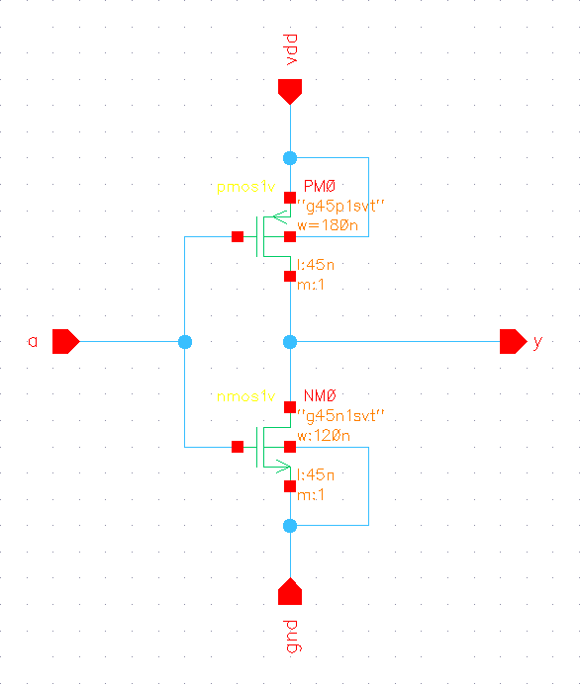
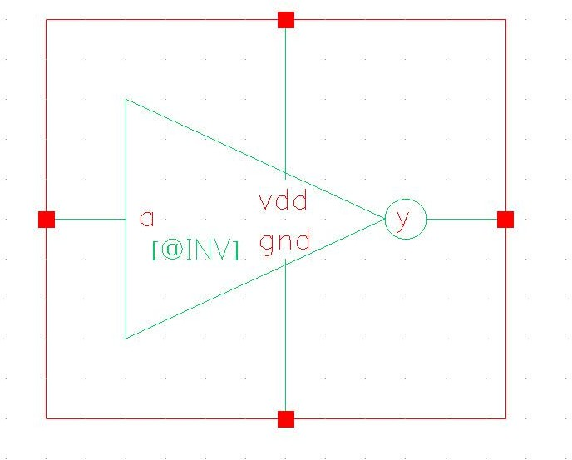

Netlist: Layout:
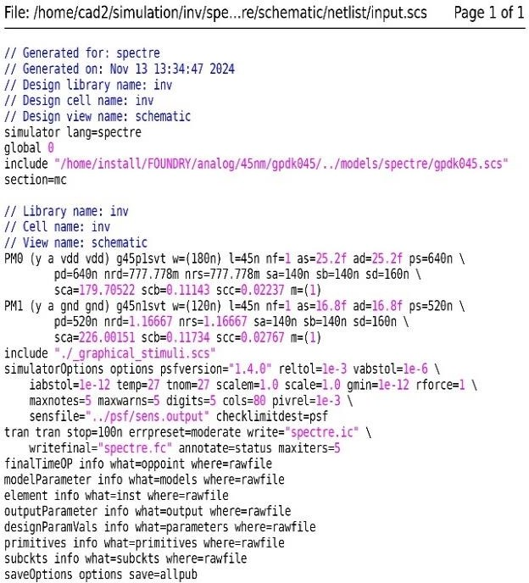
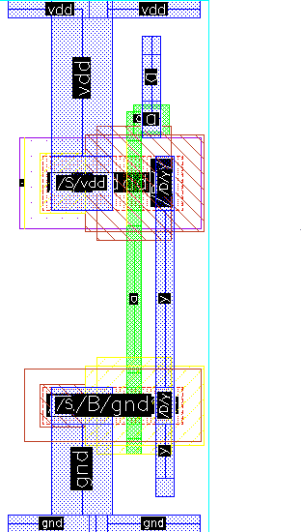

Extracted View: Abstract View:
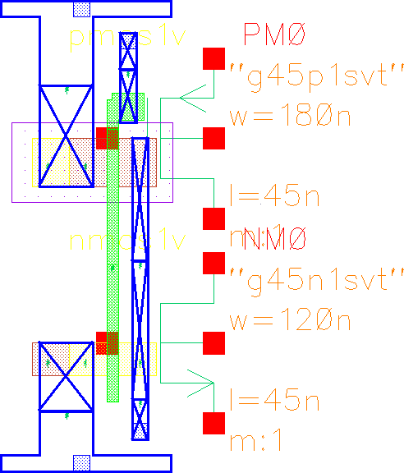
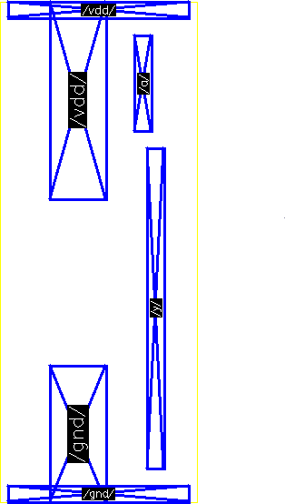

lef file: Verilog code:
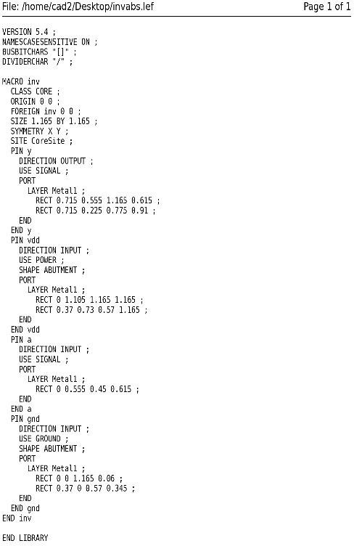
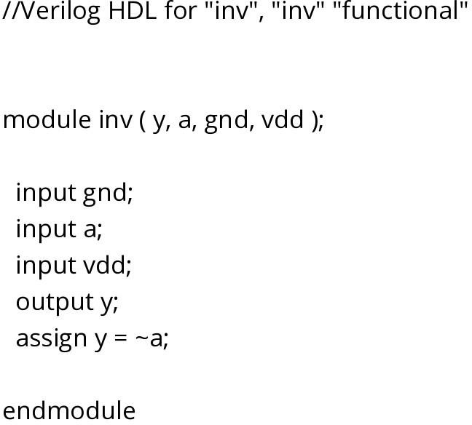

D_LATCH_POS

Symbol: Schematic:
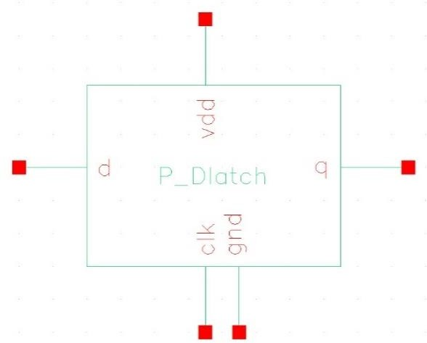
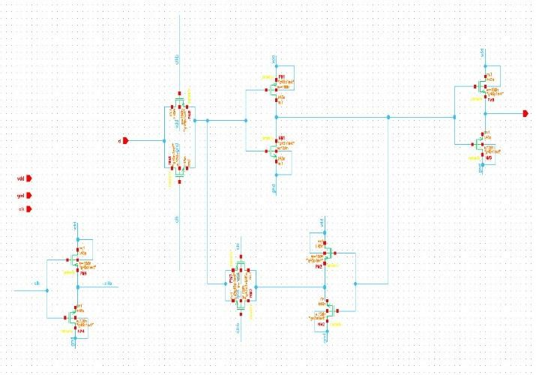

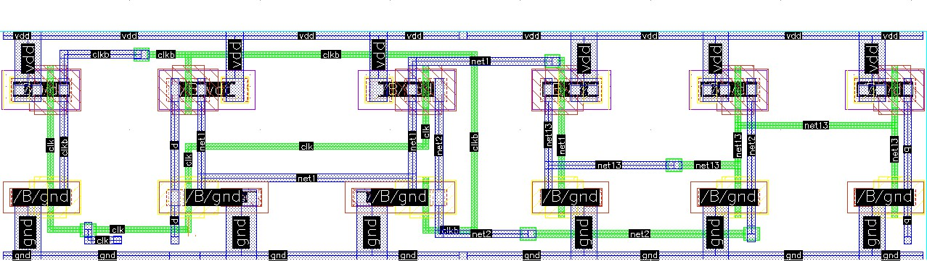
Layout:
Abstract View:
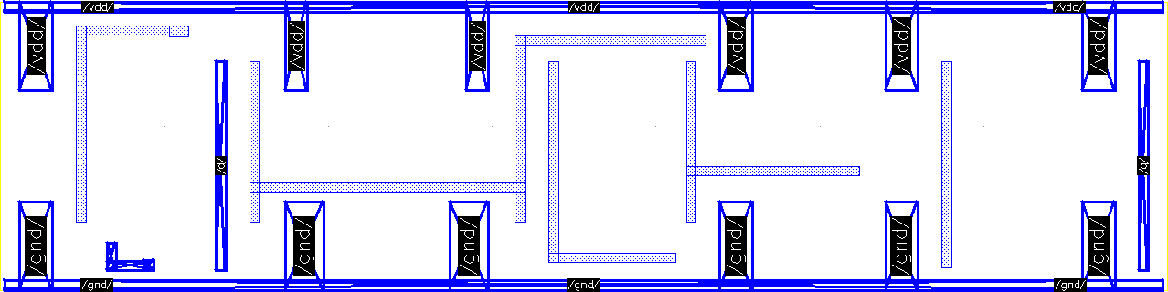

TRI_STATE_BUF
Symbol: Schematic:
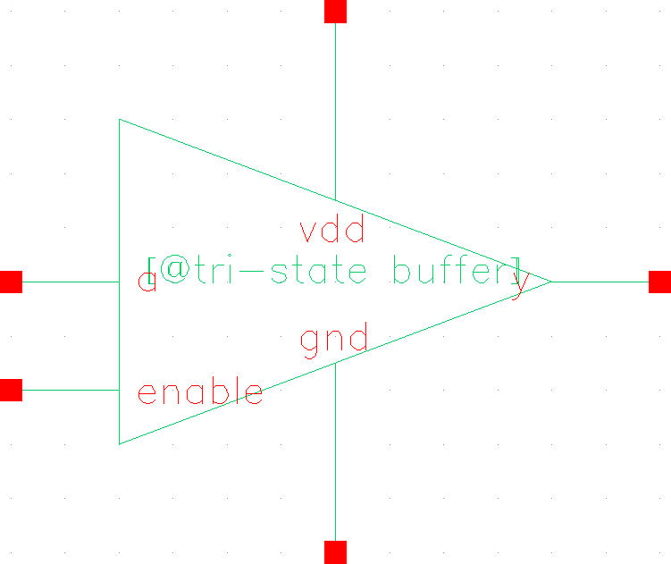
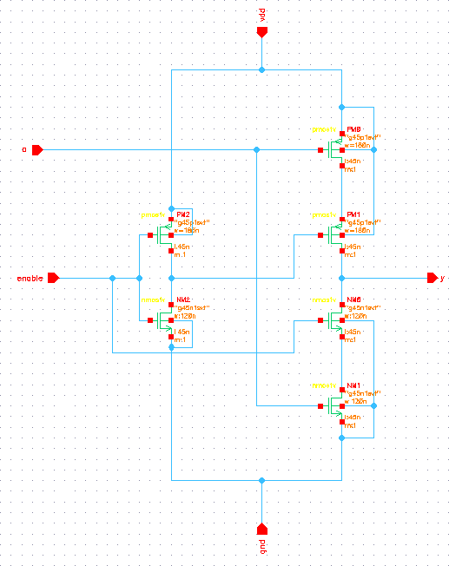

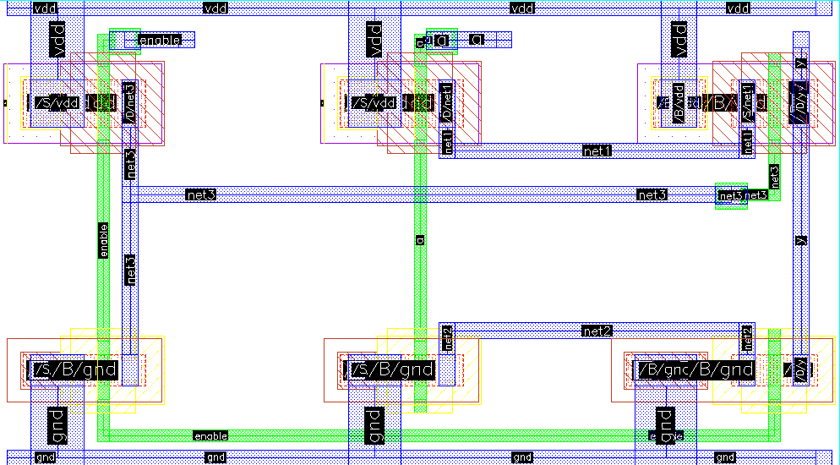
Layout:
Abstract View:
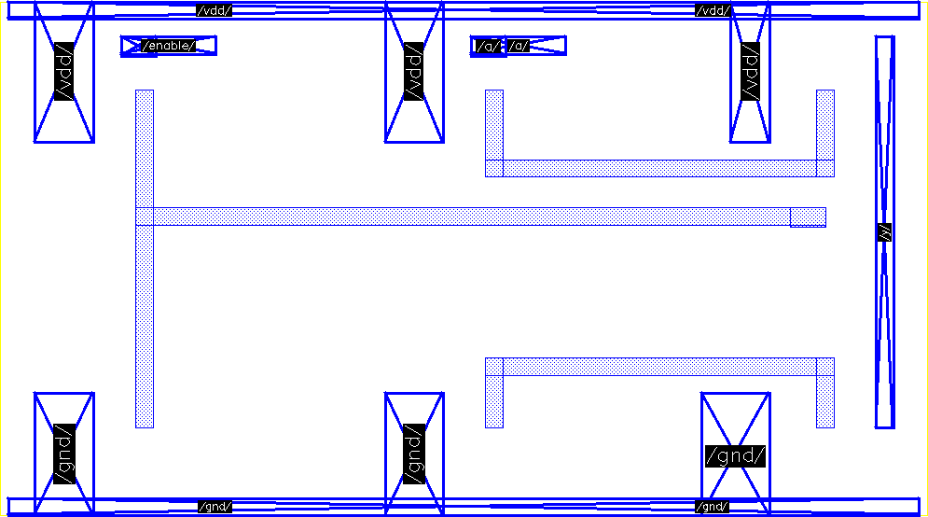

Special Cells:
DECAP: FILLER: FILLER_MIN:
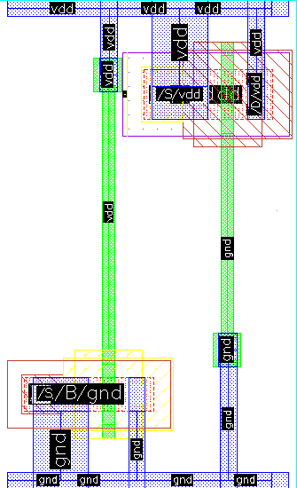
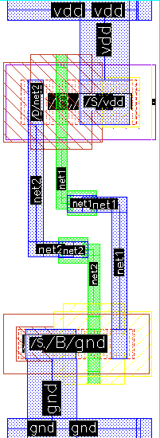
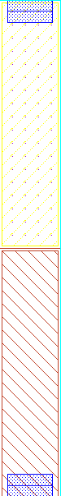

TIE_LOW: TIE_HIGH: WELL_TAP:
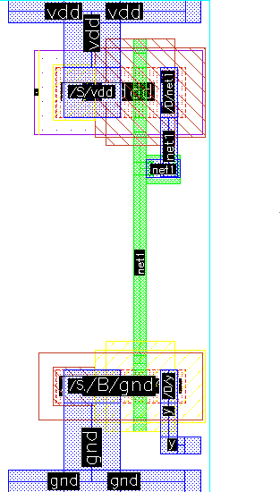
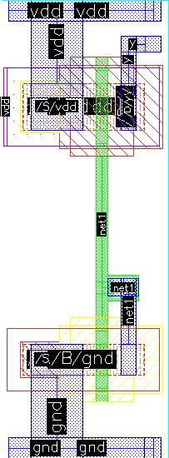
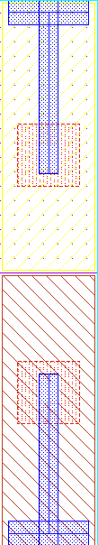

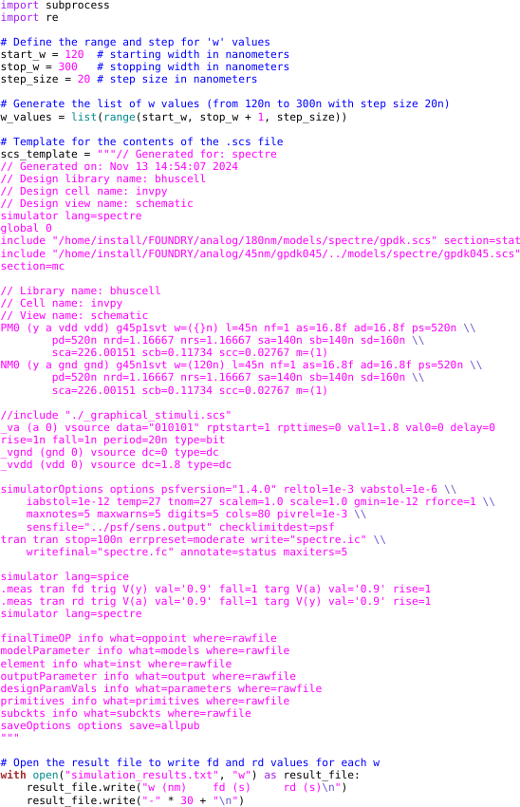
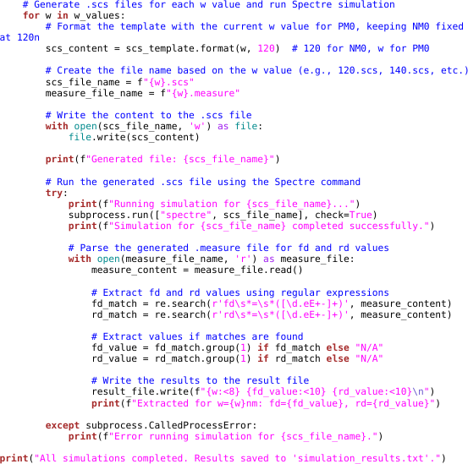
Python Script for calculating beta ratio:

Spectre Decks Created: Result of python script:
